Please visit nearby Service Canada for SIN extension and Visit Service Ontario for Insurance Extension.

**Below are the detail for visa stamping. But please note, visa stamping is not mandatory to stay in the country. It is required only if you have any travel plans.**

Please login to the below link and apply for visa extension in the passport. The complete process needs to be taken care by the associate including Biometric. TCS will reimburse CAD 100 Per head for Visa Stamping and CAD 85 Per Head for Biometric(Only if biometric not done in the last 10 Years).

In case of paper application, you need to pay biometric fees upfront and attach the fees receipt. Biometric instruction letter shall be sent by IRCC to you on email or Post after which biometric needs to be done from your side.

If incase you have already completed your biometric, then please attach the biometric completion records with all other documents and send to IRCC.  
  
[**http://www.cic.gc.ca/english/information/applications/visa.asp**](http://www.cic.gc.ca/english/information/applications/visa.asp)

**Points to be noted:**

1.If you are applying for only " Self ", Please select " Apply Online"

2.The current online visa stamping from Canada and out side Canada is taking 12 Weeks of time.

3. If you are applying for " Self along with Dependents" who are on Visitor Visa, Please select " Apply On Paper".

4. If you are applying only for " Dependents" who are on Visitor visa , Please select " Apply On Paper".

There is an error in CIC online system and it's not approving visa extension for dependents who are on Visitor Visa if applied Online.

WP holders and Student permit holders can apply visa extension online. But you will have to create a separate profile for students and submit the documents.

Please do not include student permit holders as your dependents in the profile. You will have to create separate profile for students even if they are Minor.

**Please note: Currently all paper application process is on hold until 31-May-2021. So you can’t submit visa stamping request for your dependents on Visitor Visa within Canada until end of March. If dependents holding open work permit, then you can submit online visa stamping process. But not for Visitor Visa holders.**

Login to the below link and sign in as GC Key holder. And then select Visitor Visa, Study and / or Work permit.

Please click the below link.

[**http://www.cic.gc.ca/english/information/applications/visa.asp**](http://www.cic.gc.ca/english/information/applications/visa.asp)

**Click Apply Online for a Visa.**

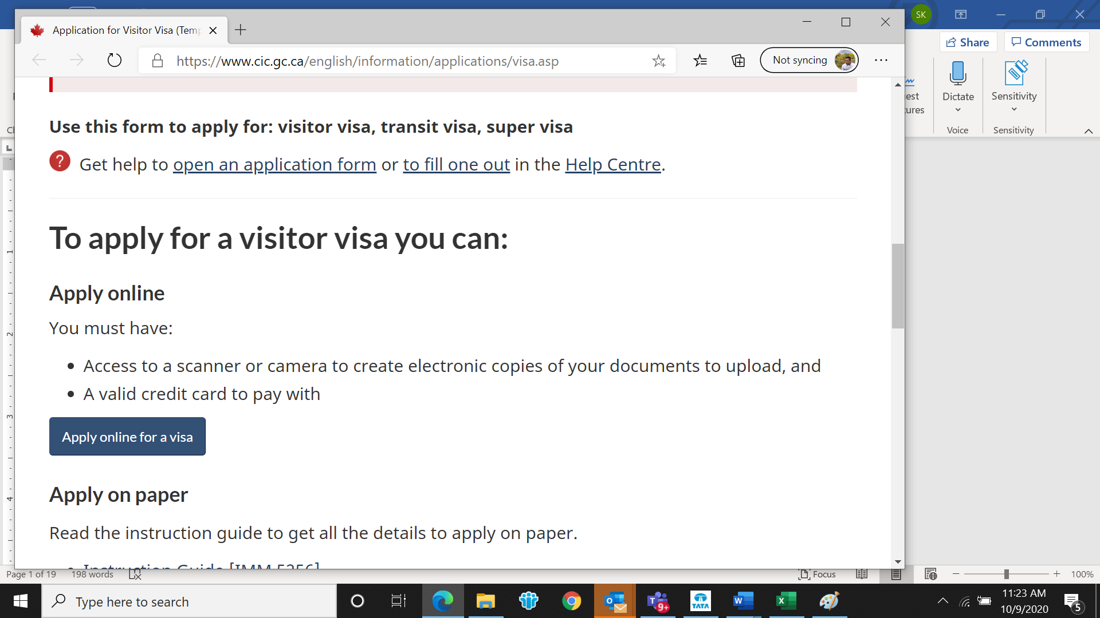

Click Sign in with GC Key.

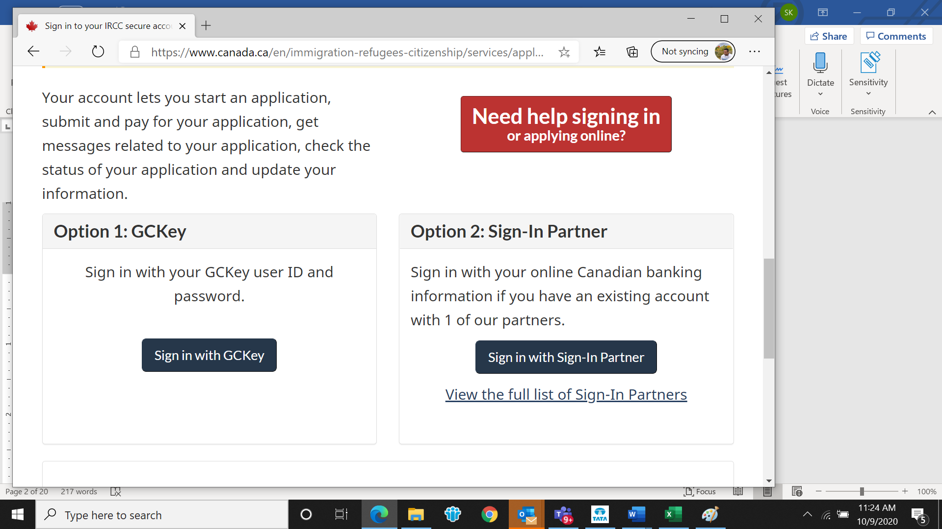

Click Signup (If you want to create a new profile ). If you already have one, then please mention user name and password and enter.

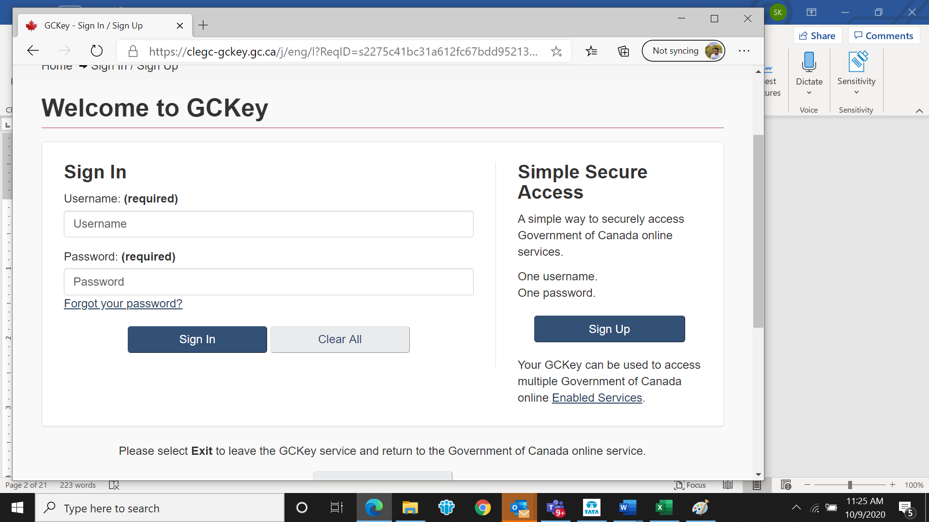

Click Visitor visa , study and/or work permit

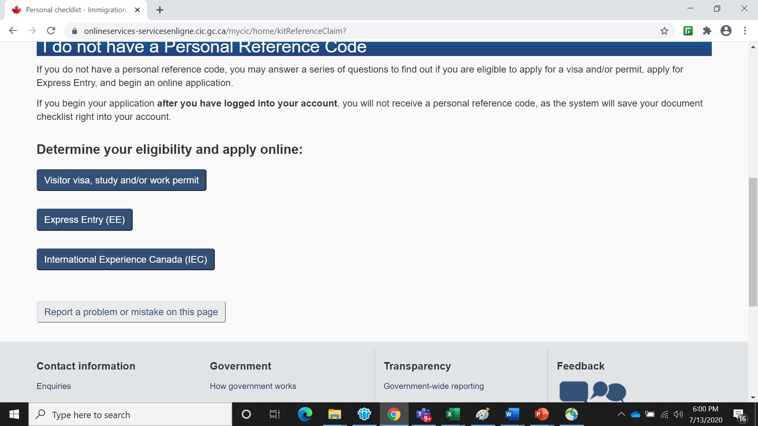

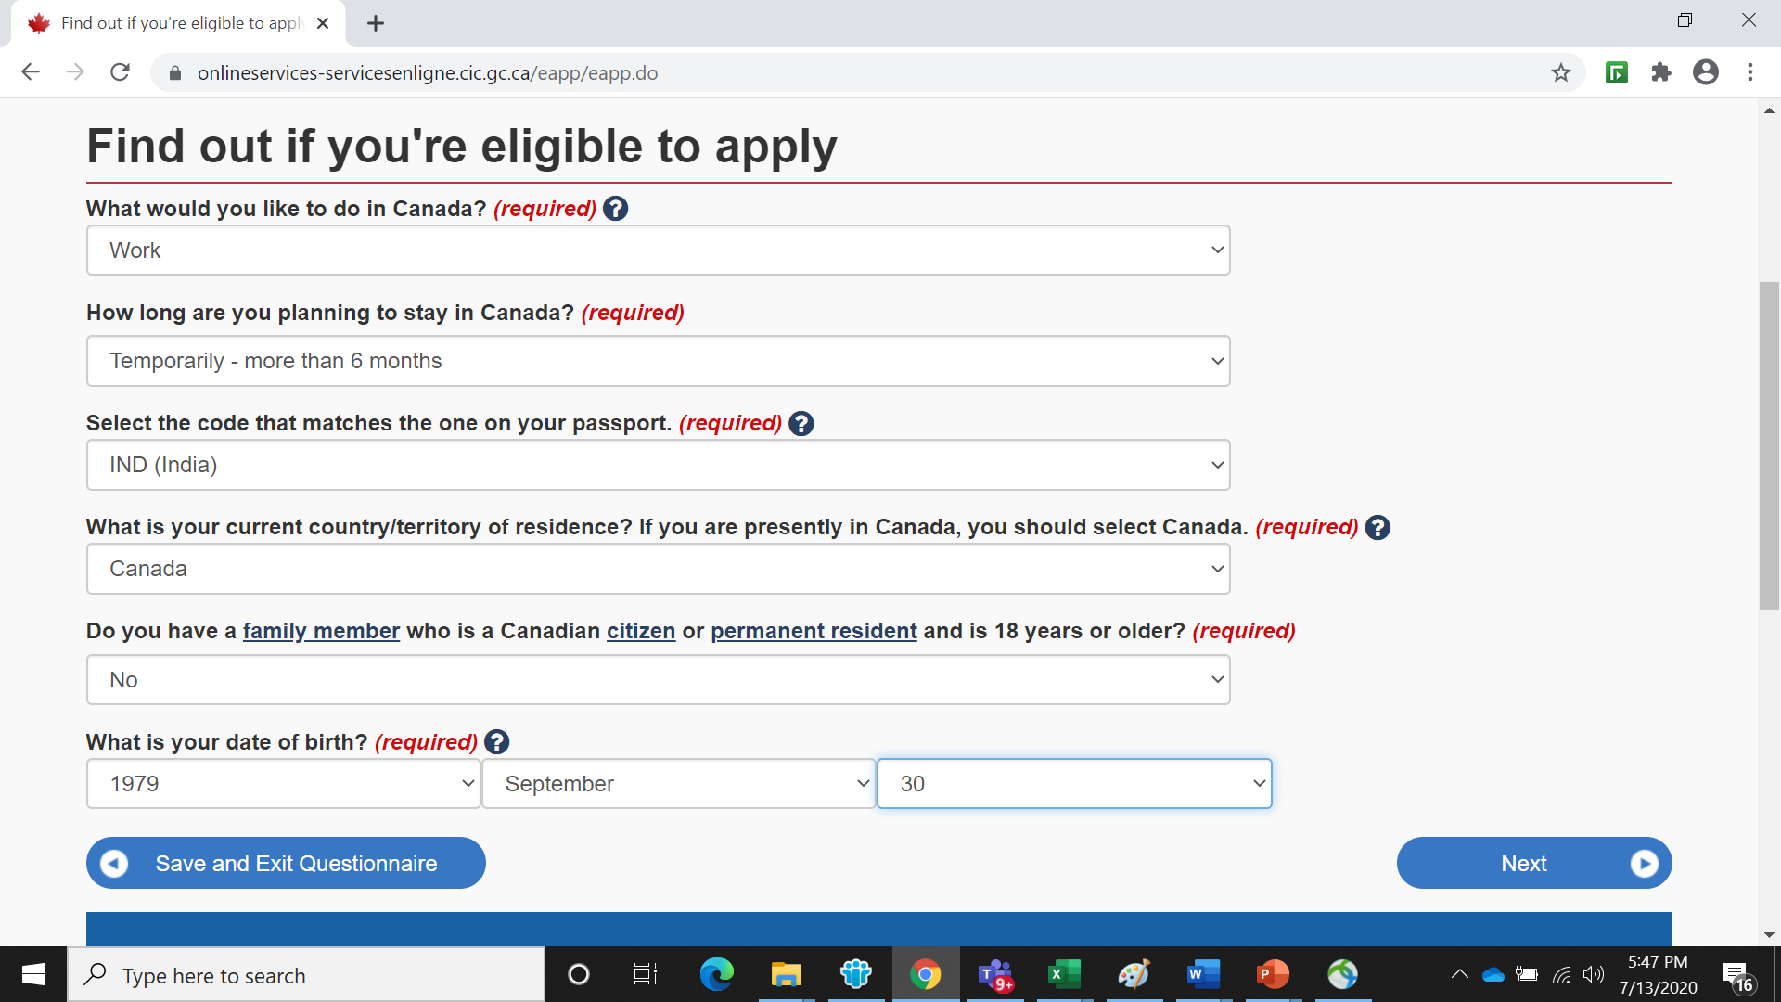

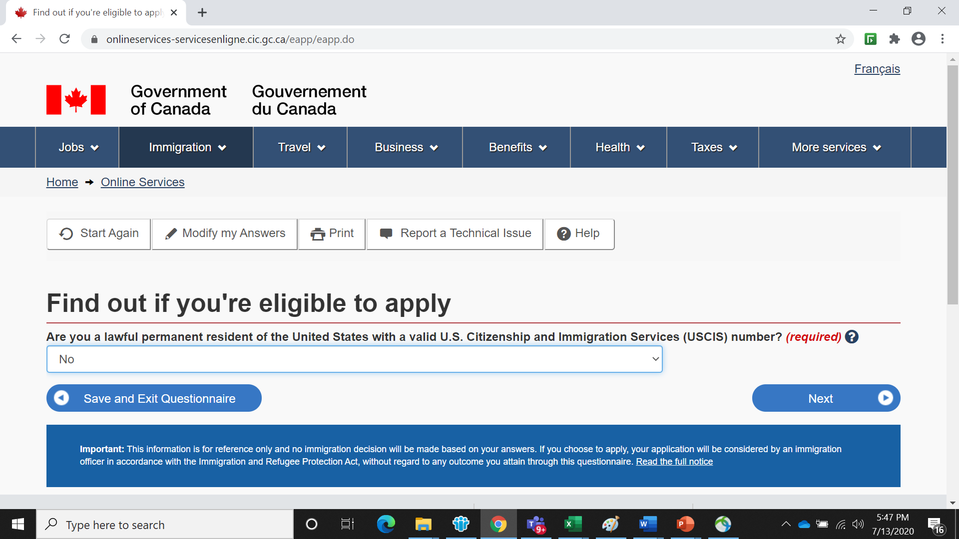

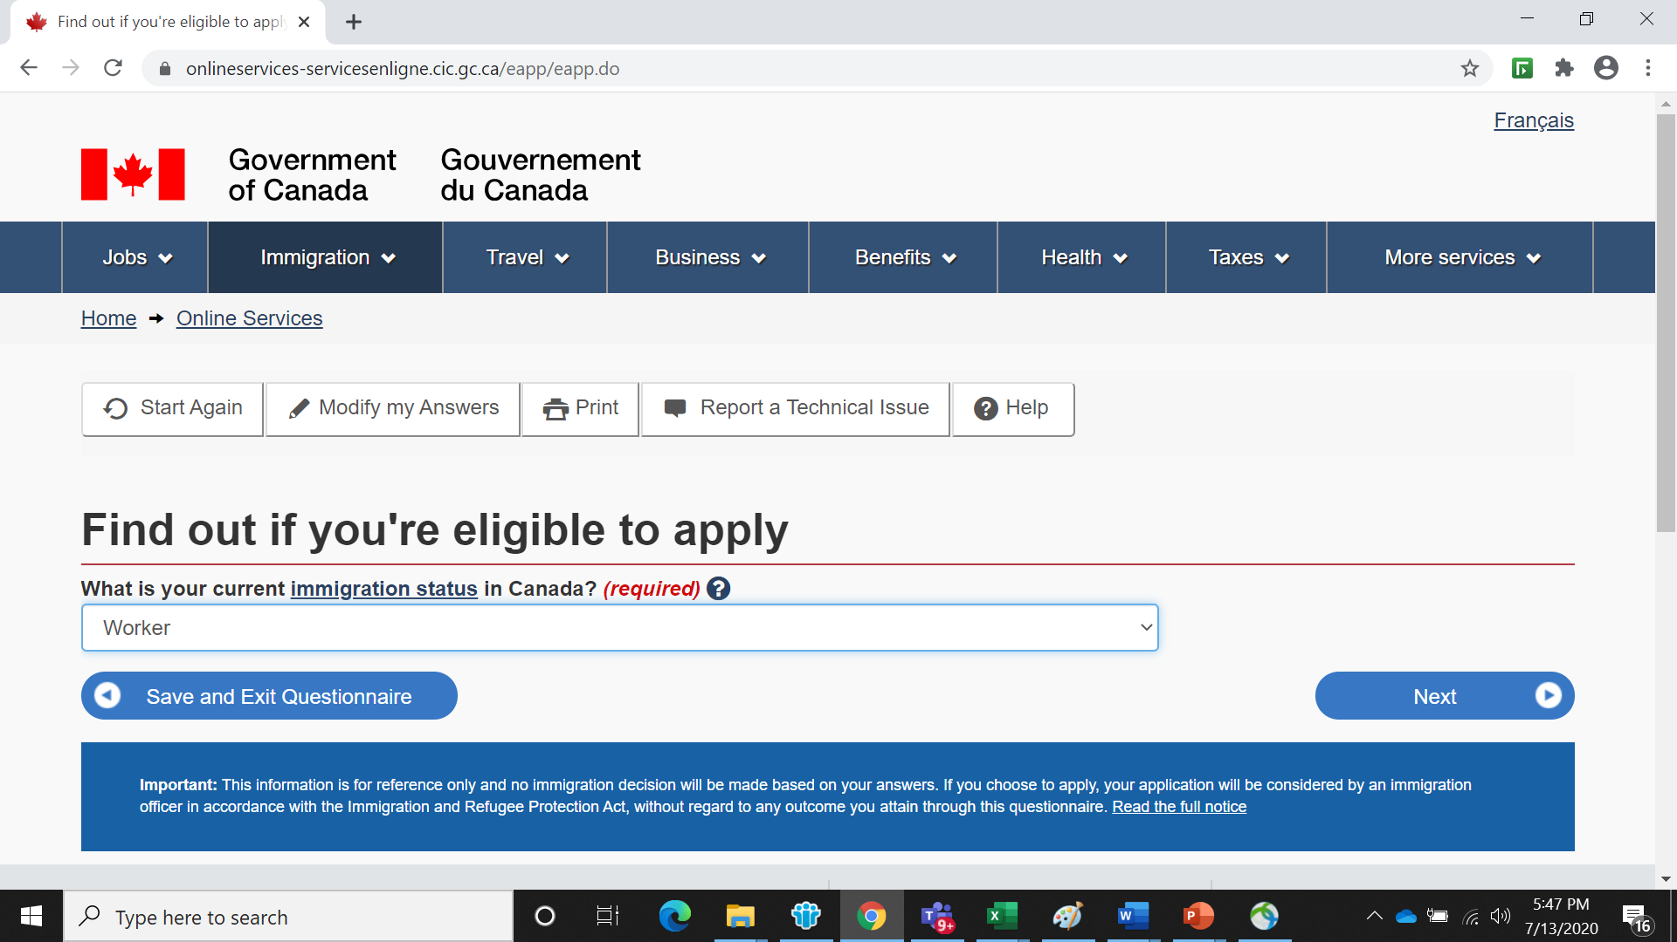

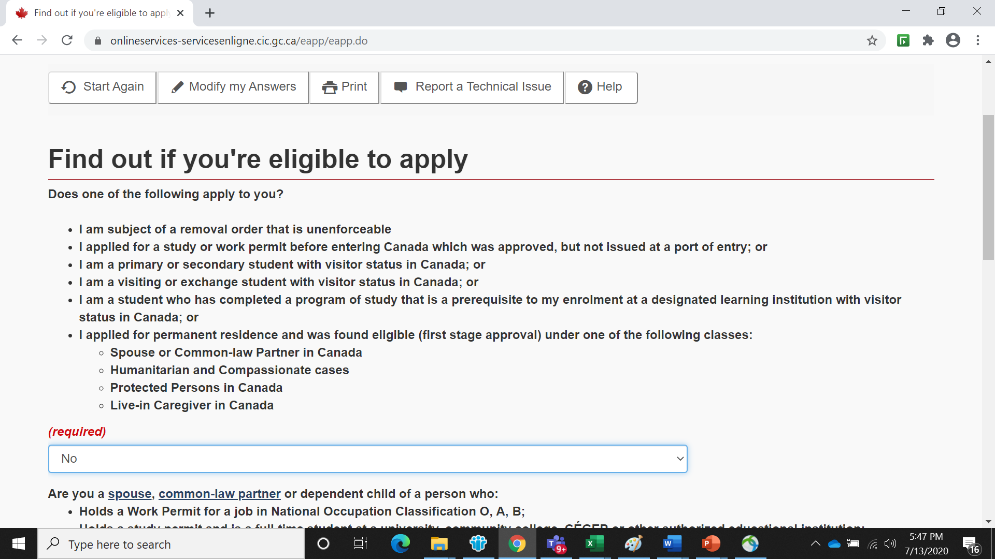

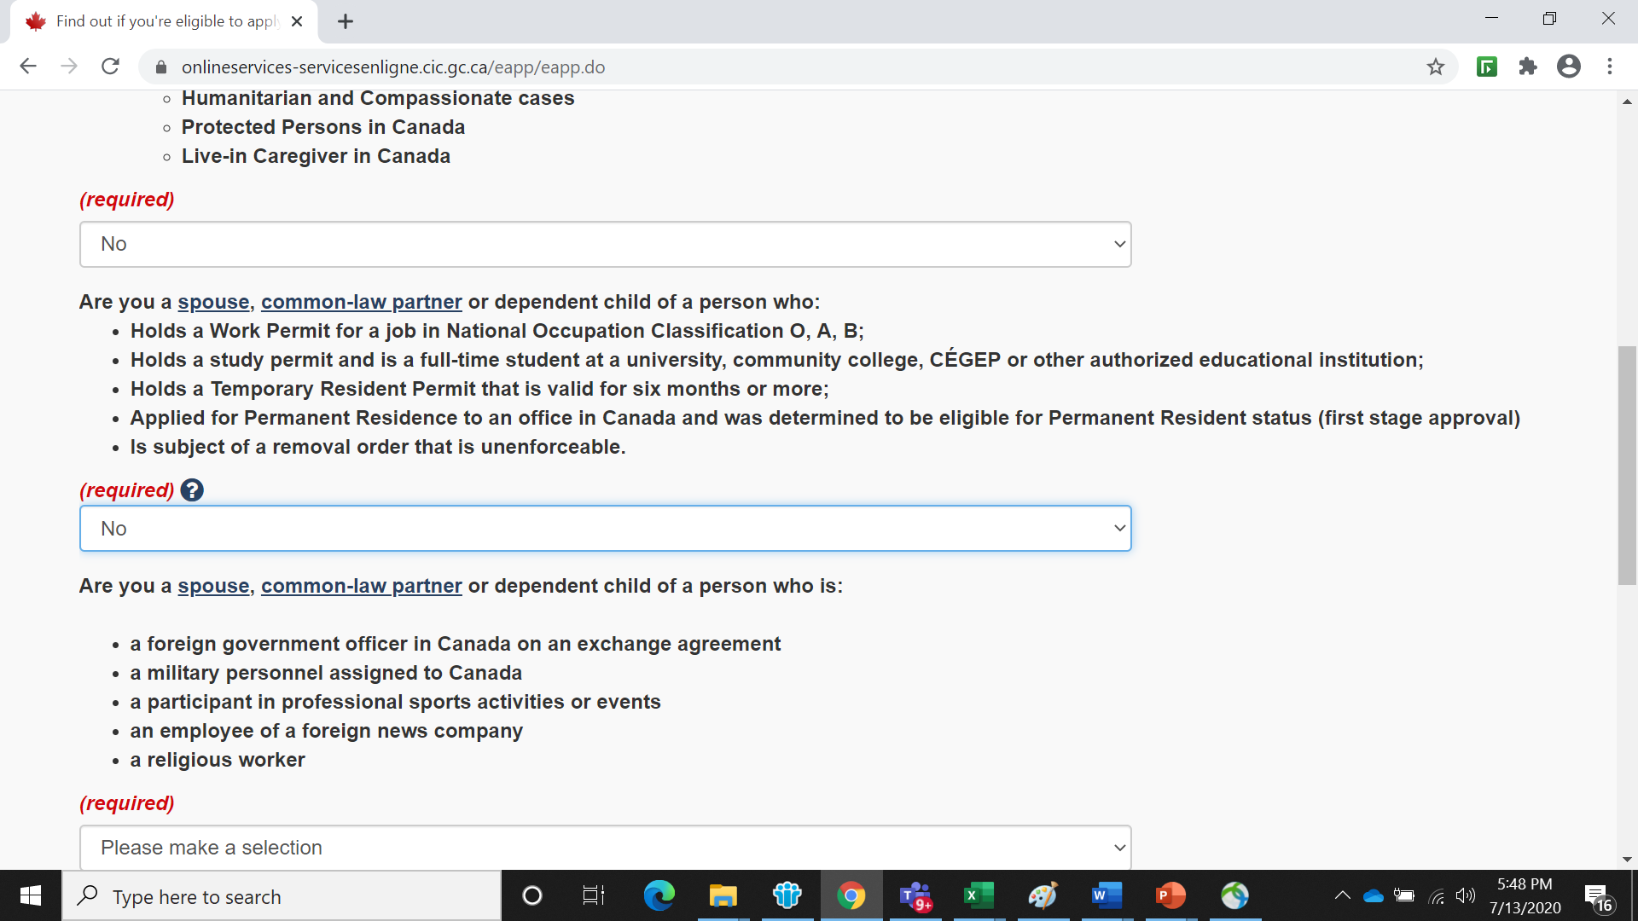

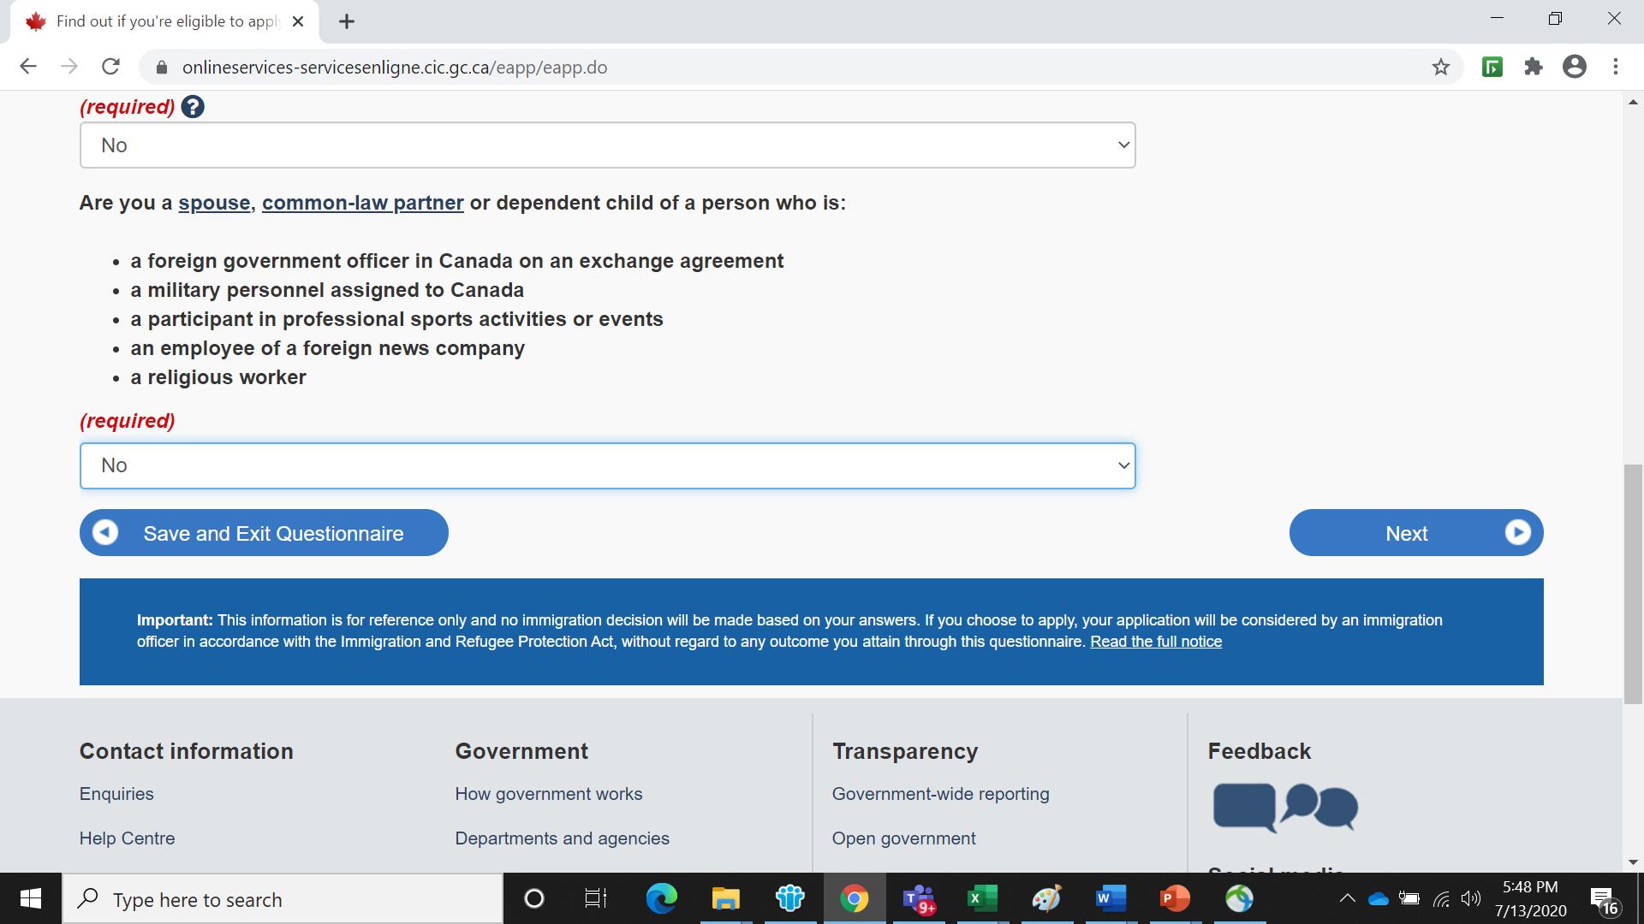

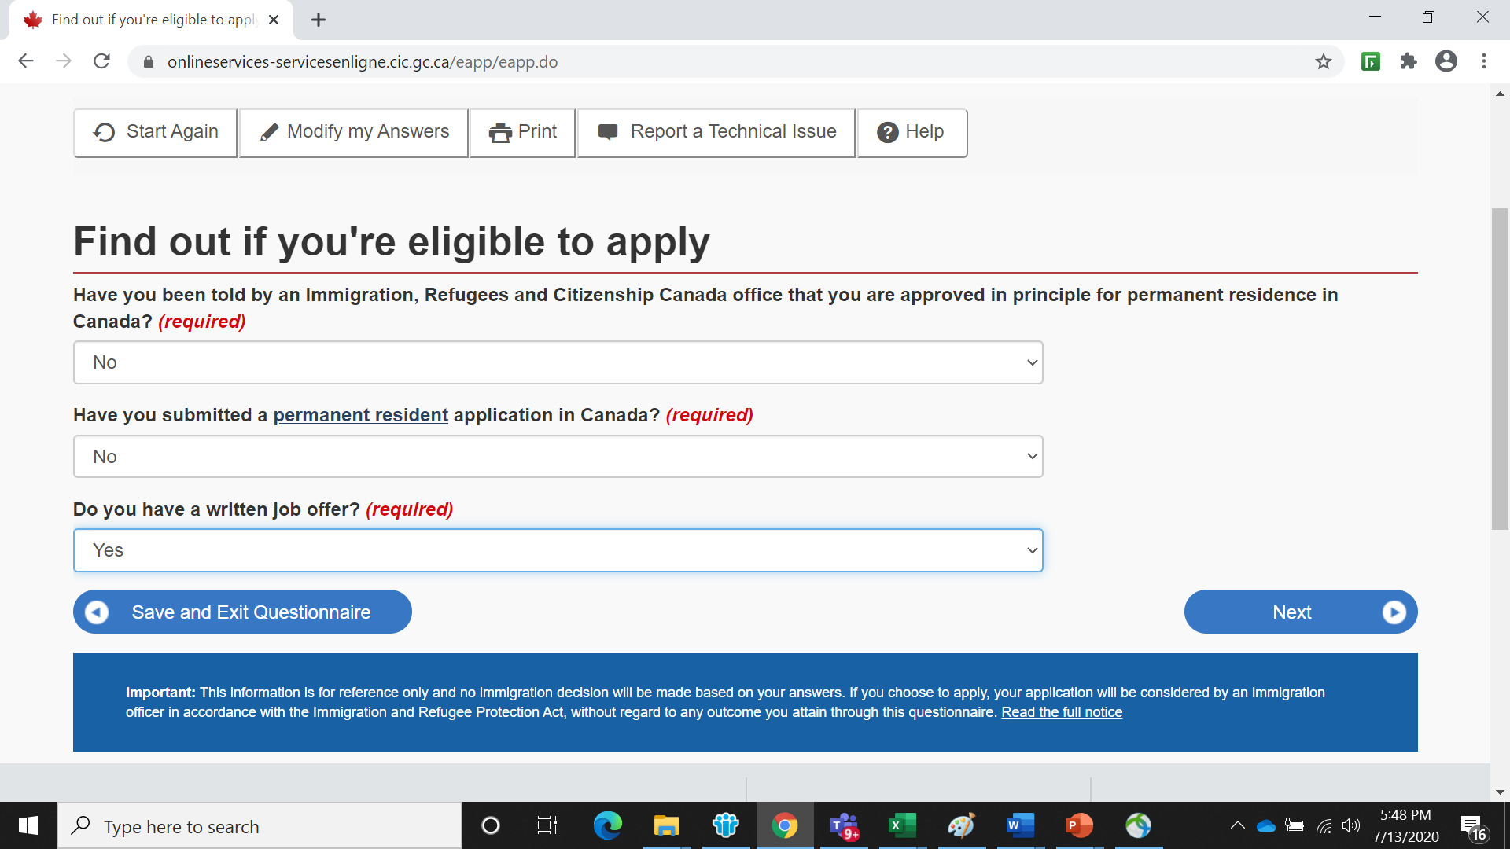

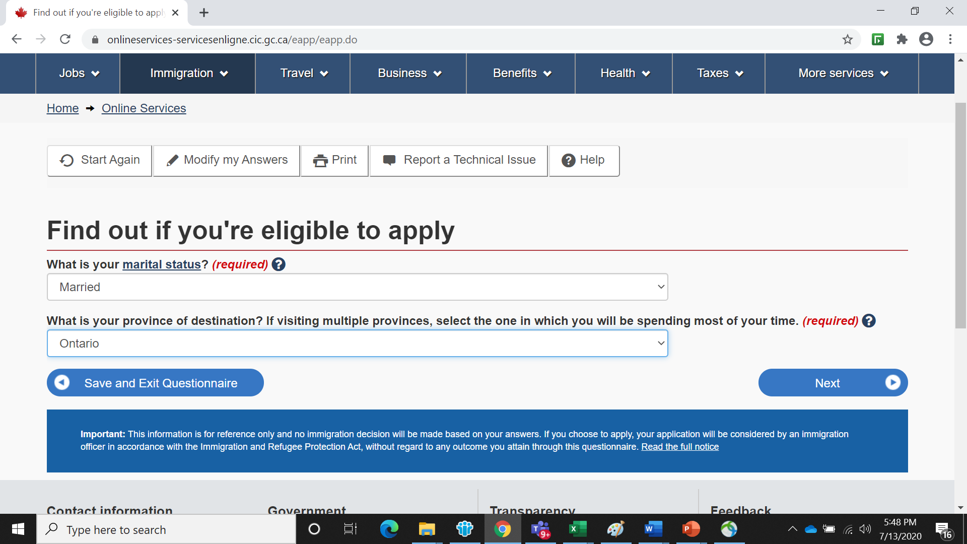

Please look into the below two TAB. You should select the second one Temporary Resident Visa and select " Visitor Visa " for all. Please do not pay fee for Work permit or Study permit extension. the visa fee is only CAD 100 Per Head for all category. You are not supposed to select the first one " Work permit”. You already have a work permit.

You should select the Second option “ Temporary Resident Visa” ( Do not select work permit)

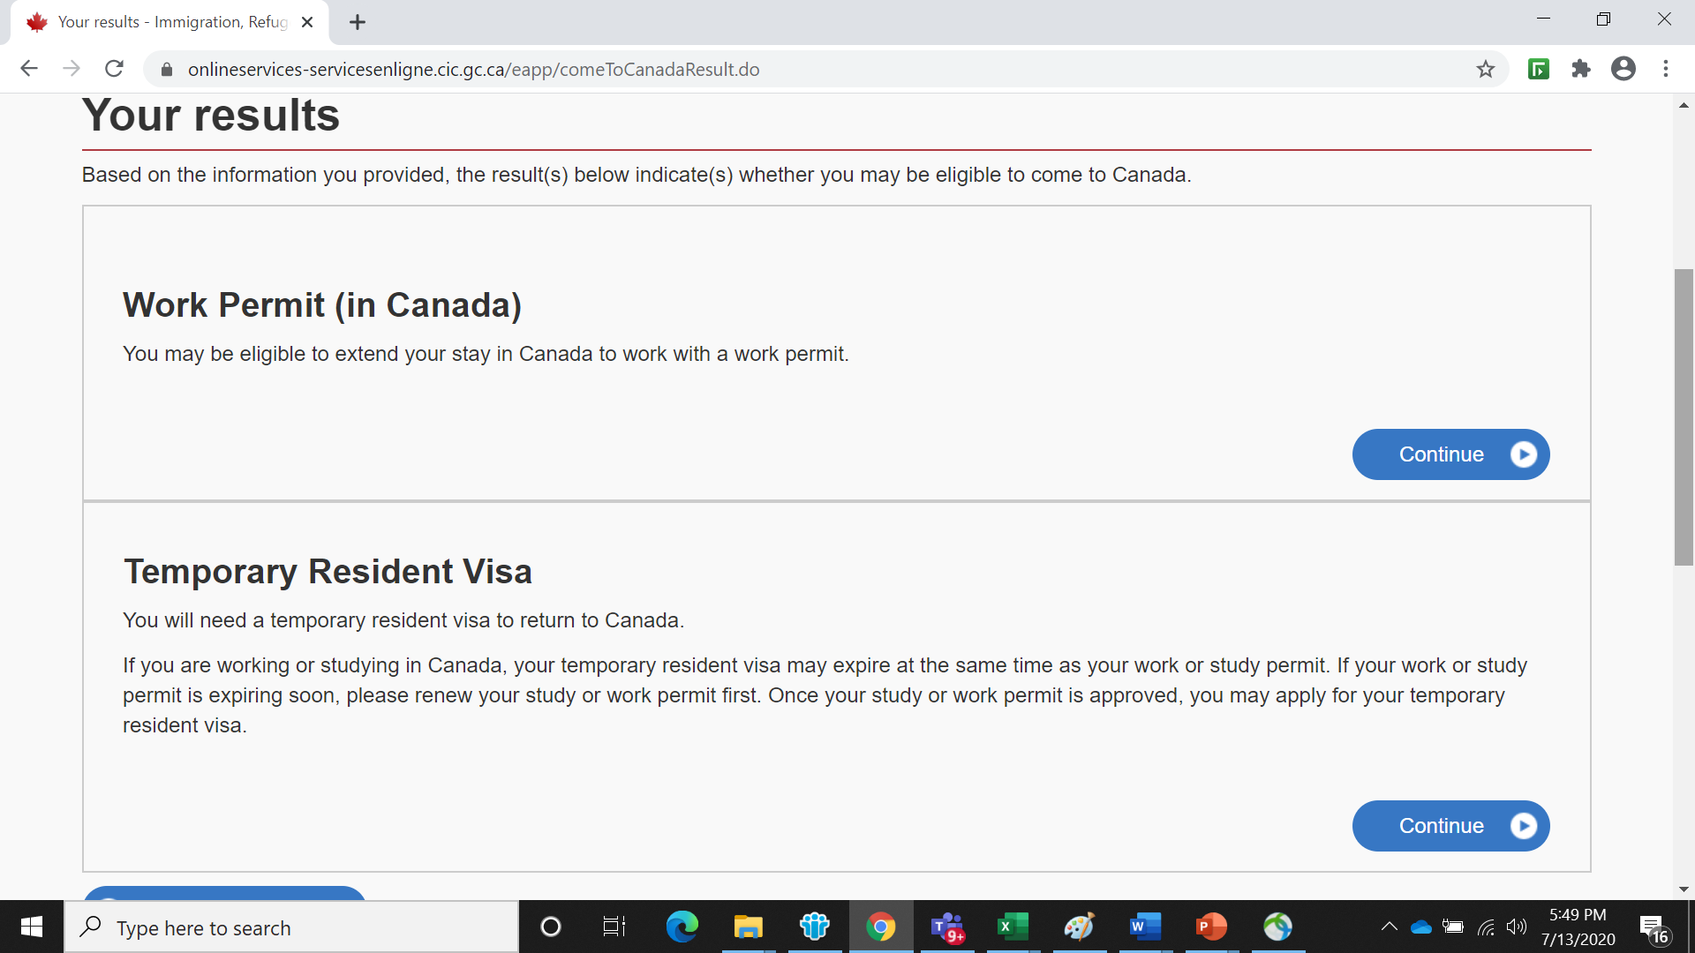

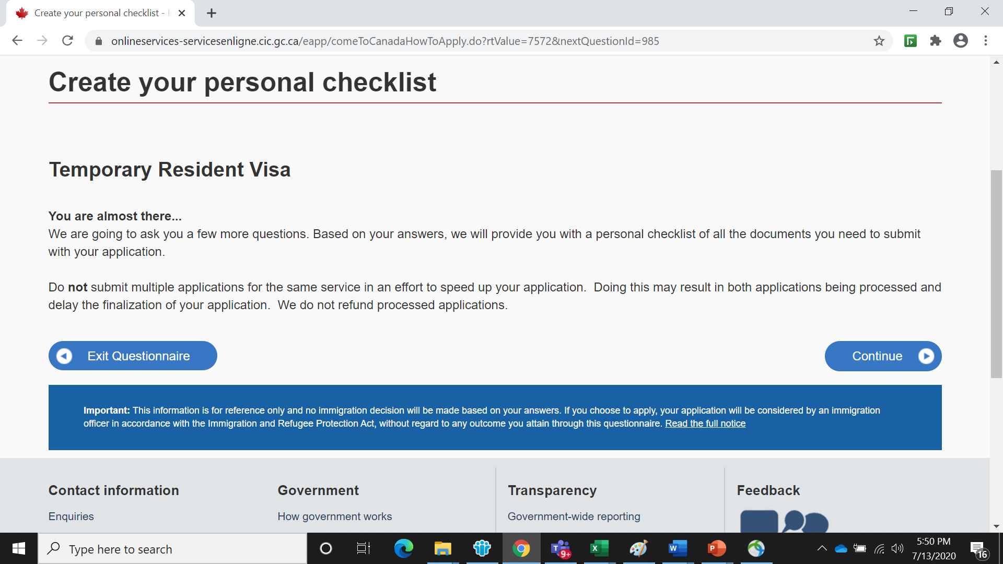

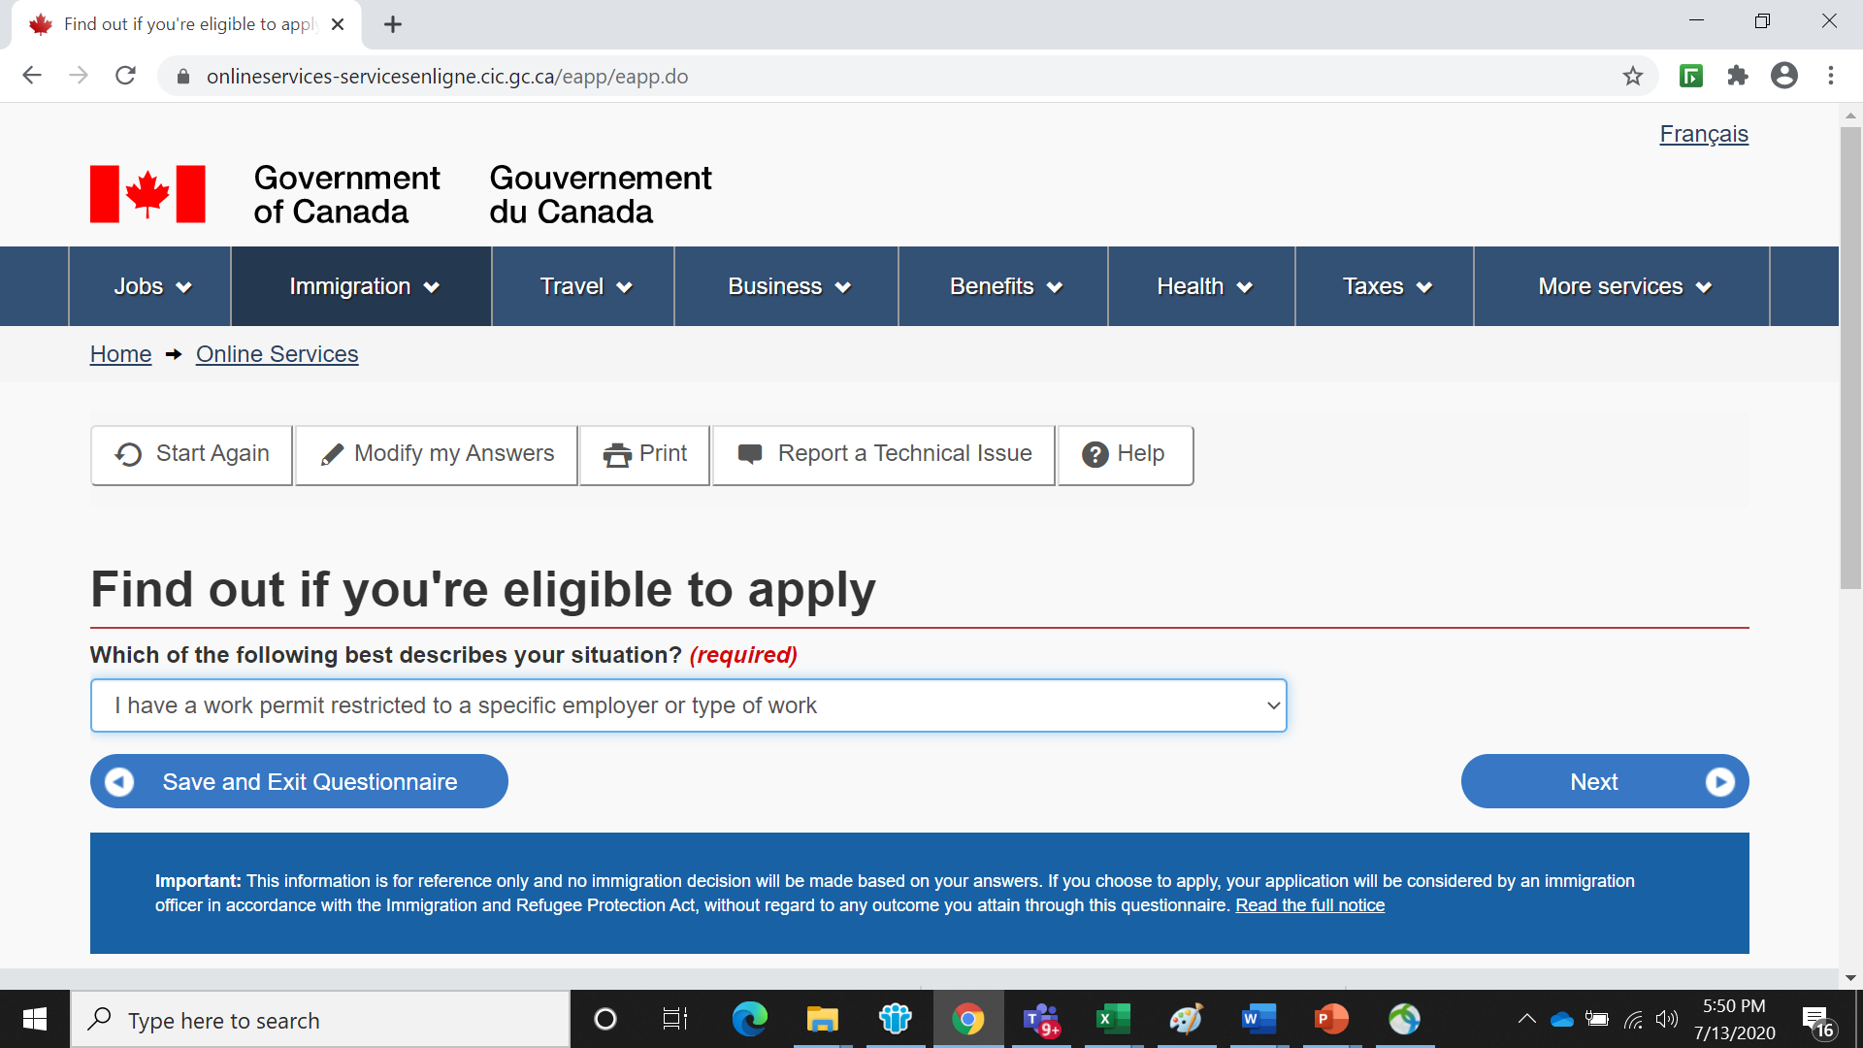

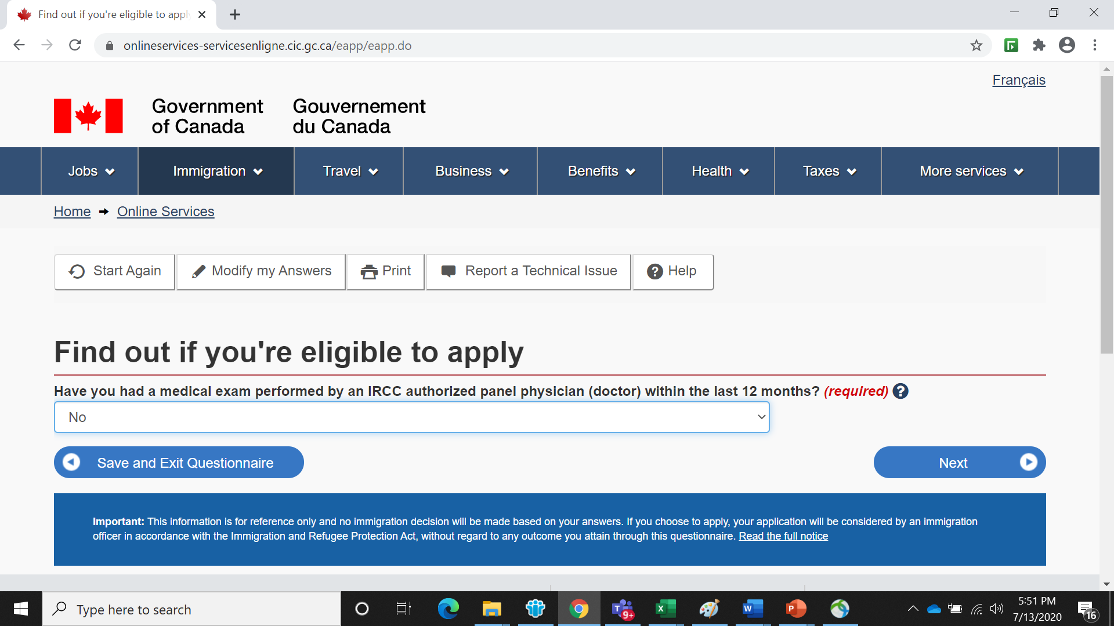

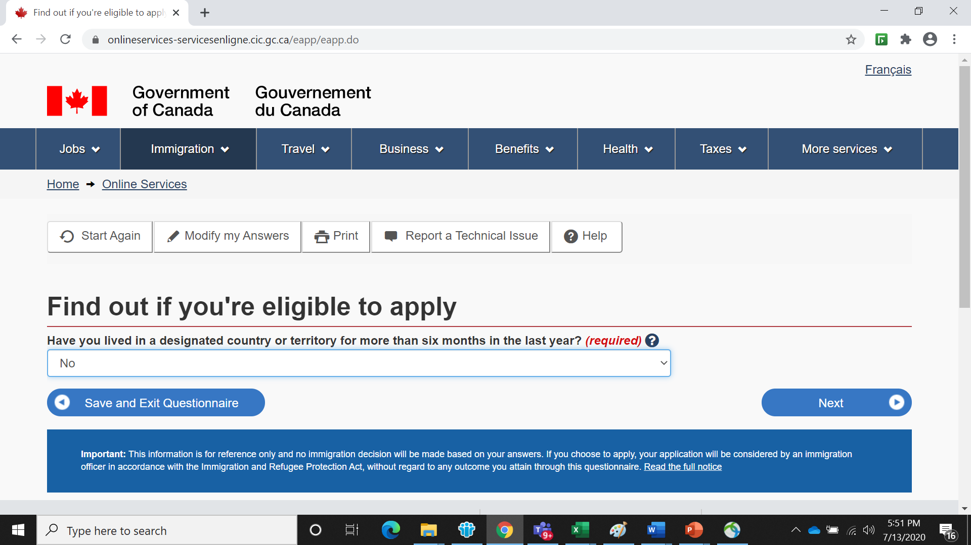

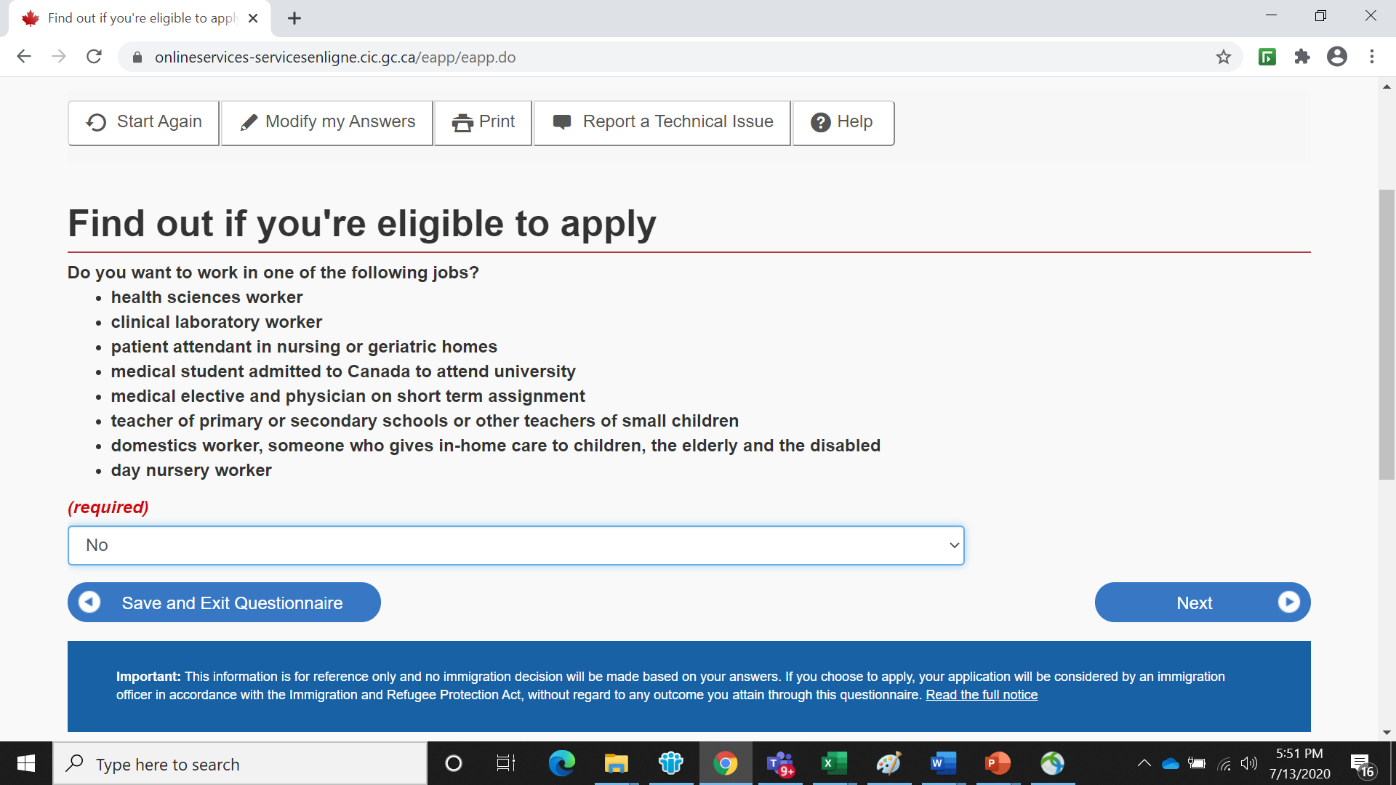

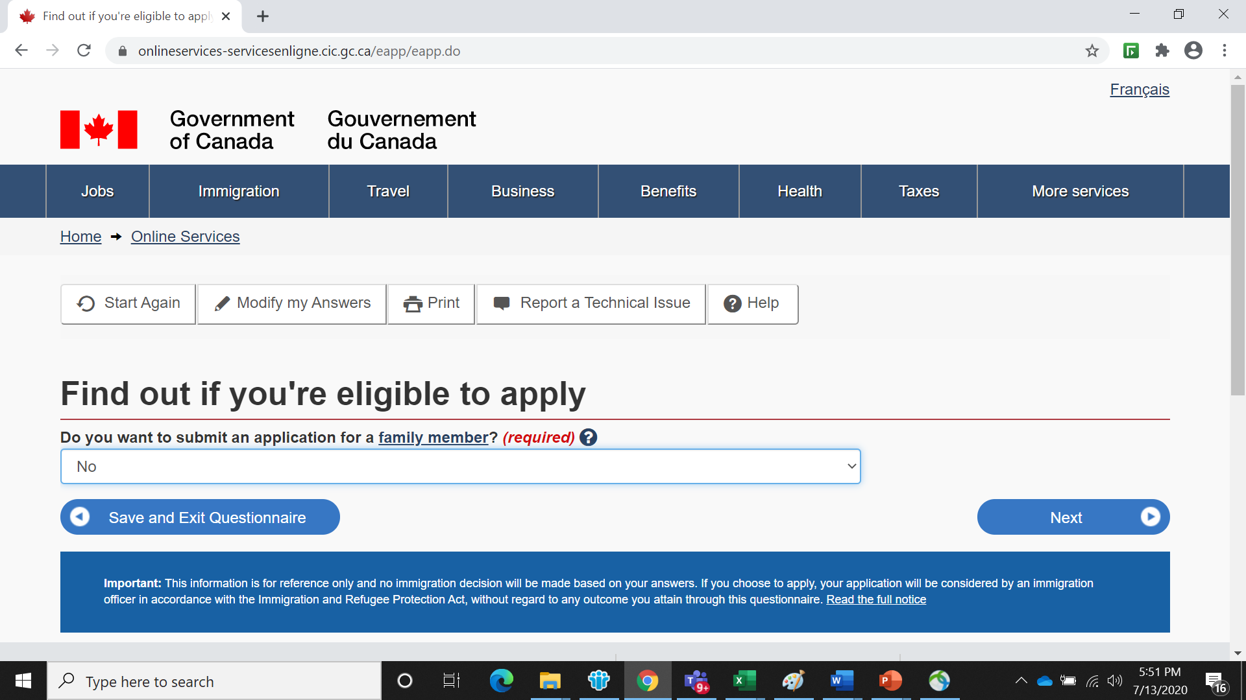

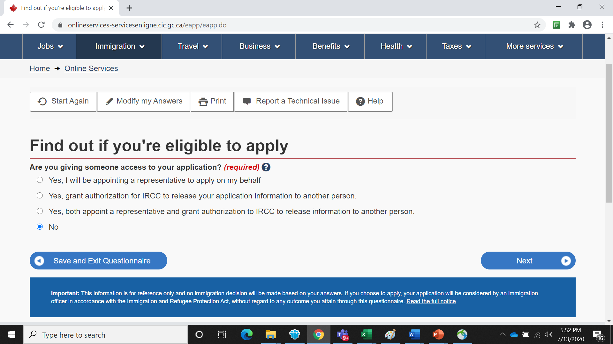

Select “ Yes” if you have completed biometric process during your fresh application process or any of your WP extension process. Select “ NO” if you have not completed biometric. If Selected “ NO “ You should pay additional CAD 85 and complete the biometric process upon receiving the instruction letter after submitting your profile along with visa fee and biometric fee.

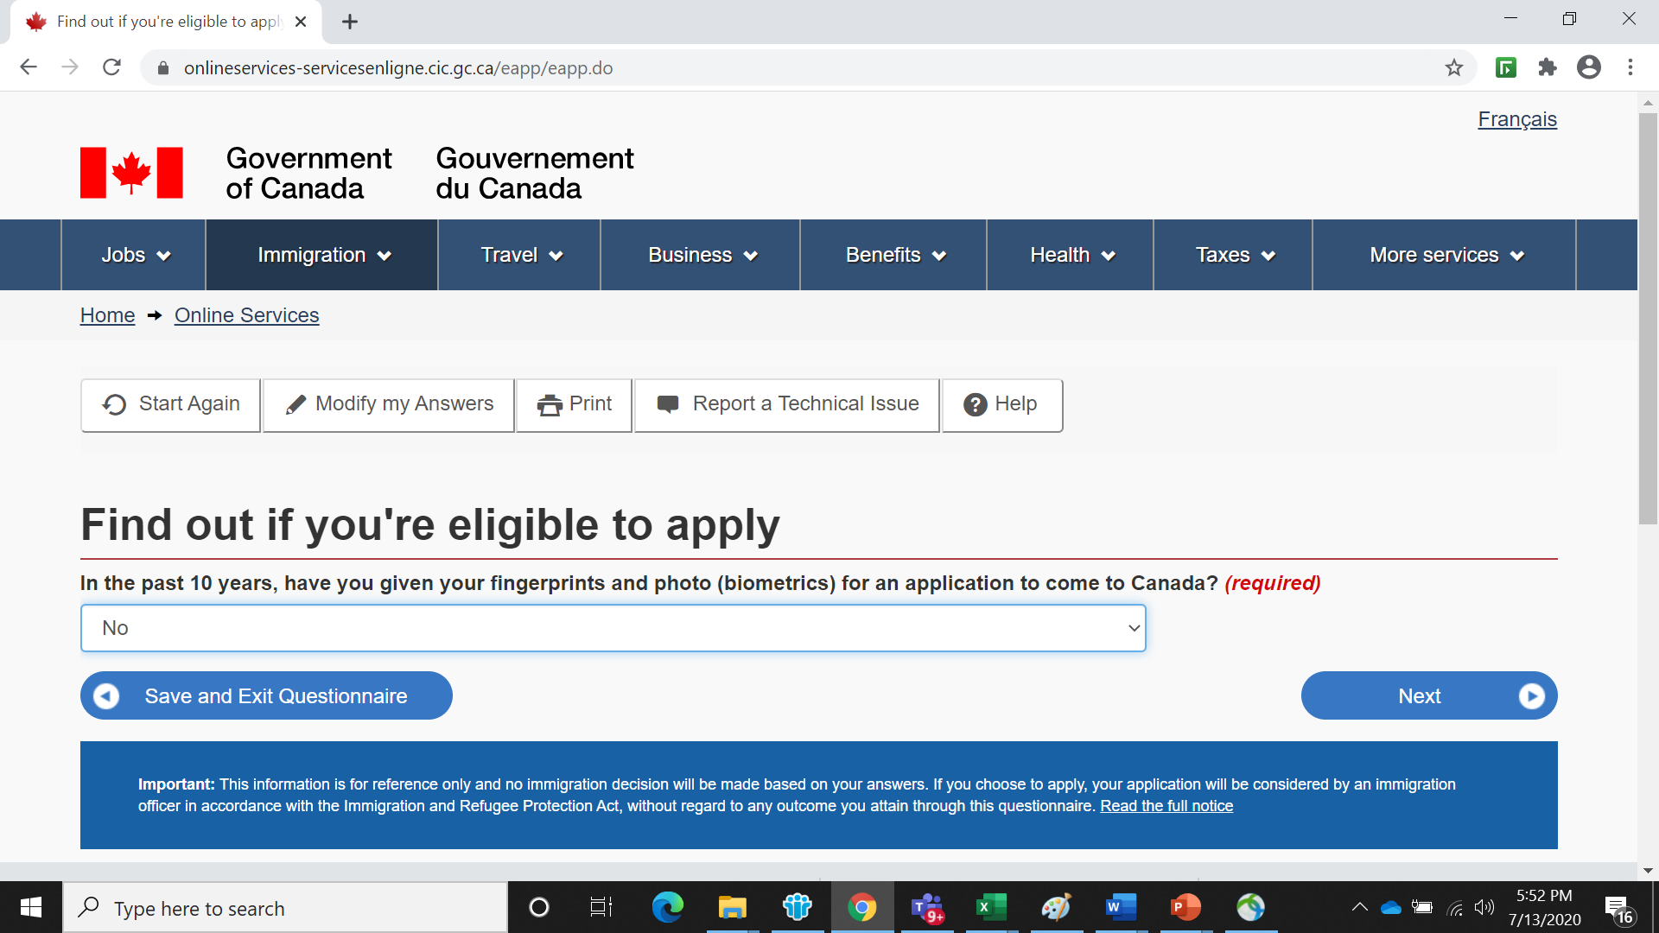

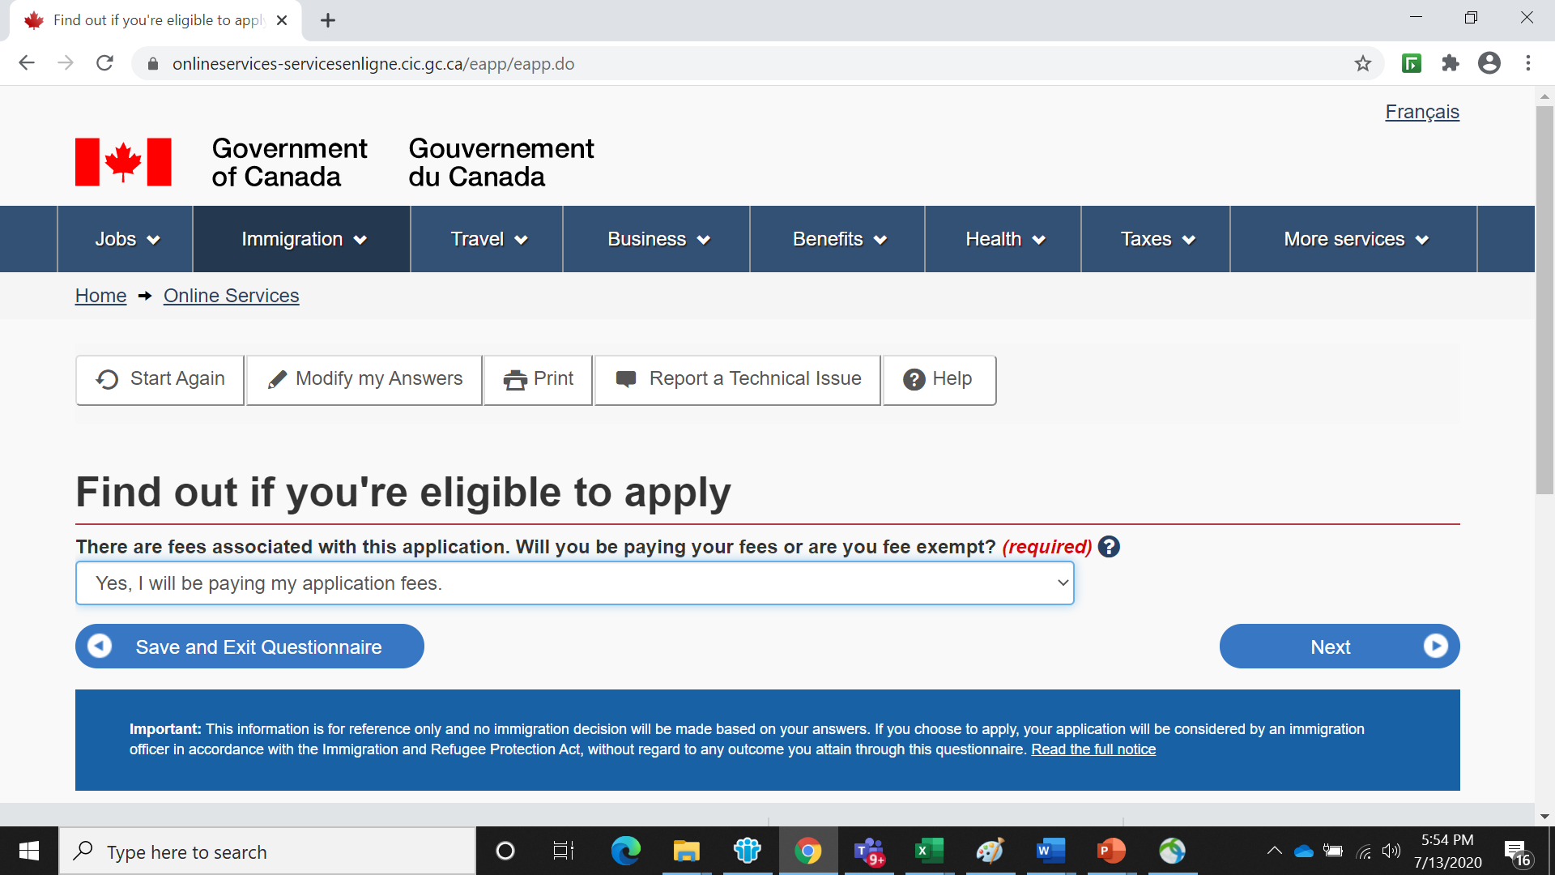

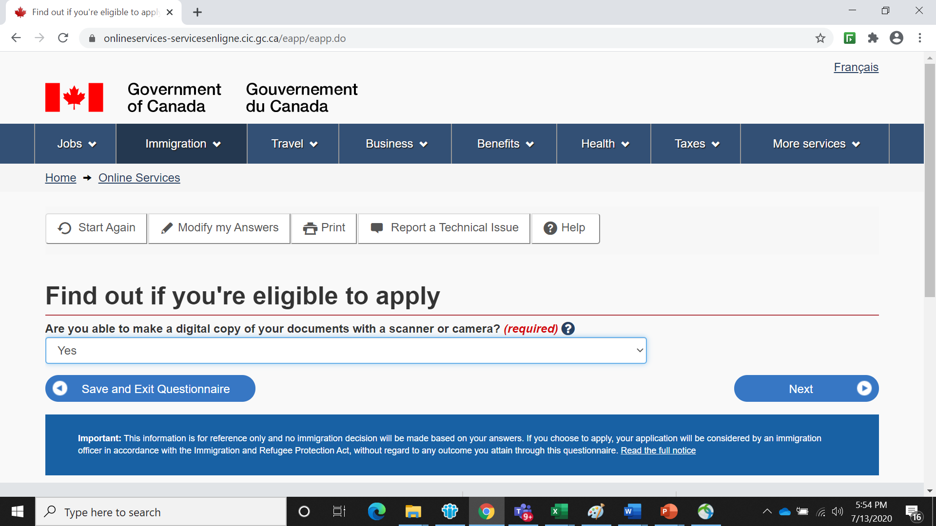

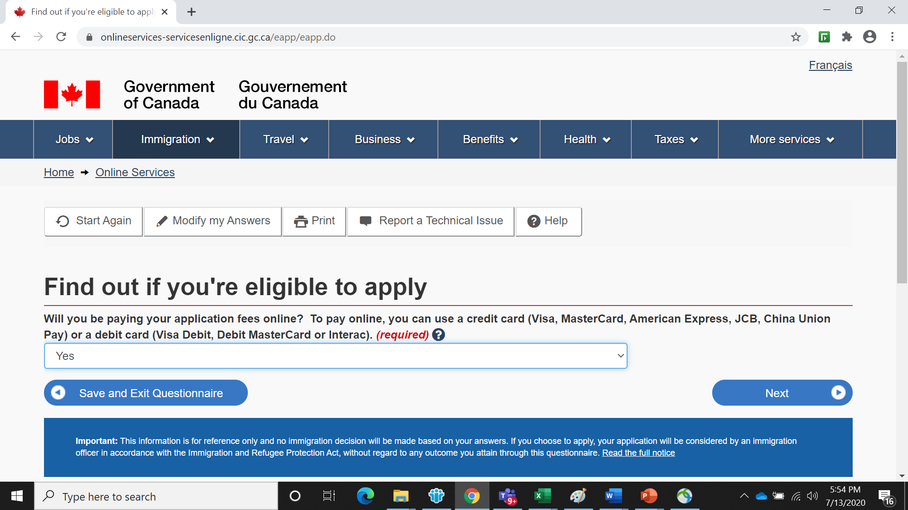

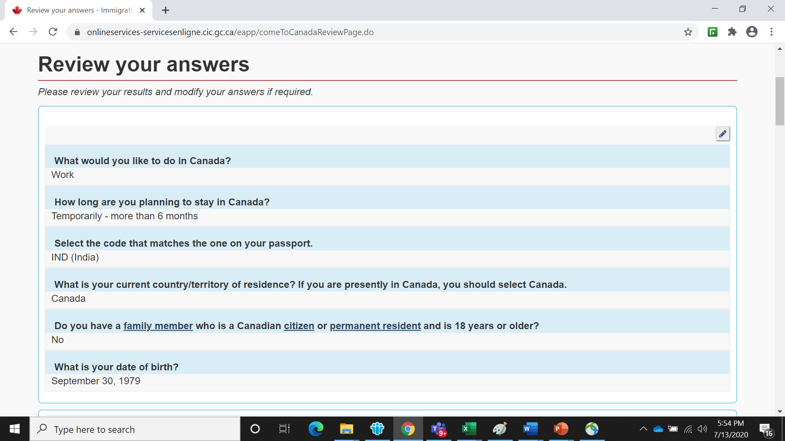

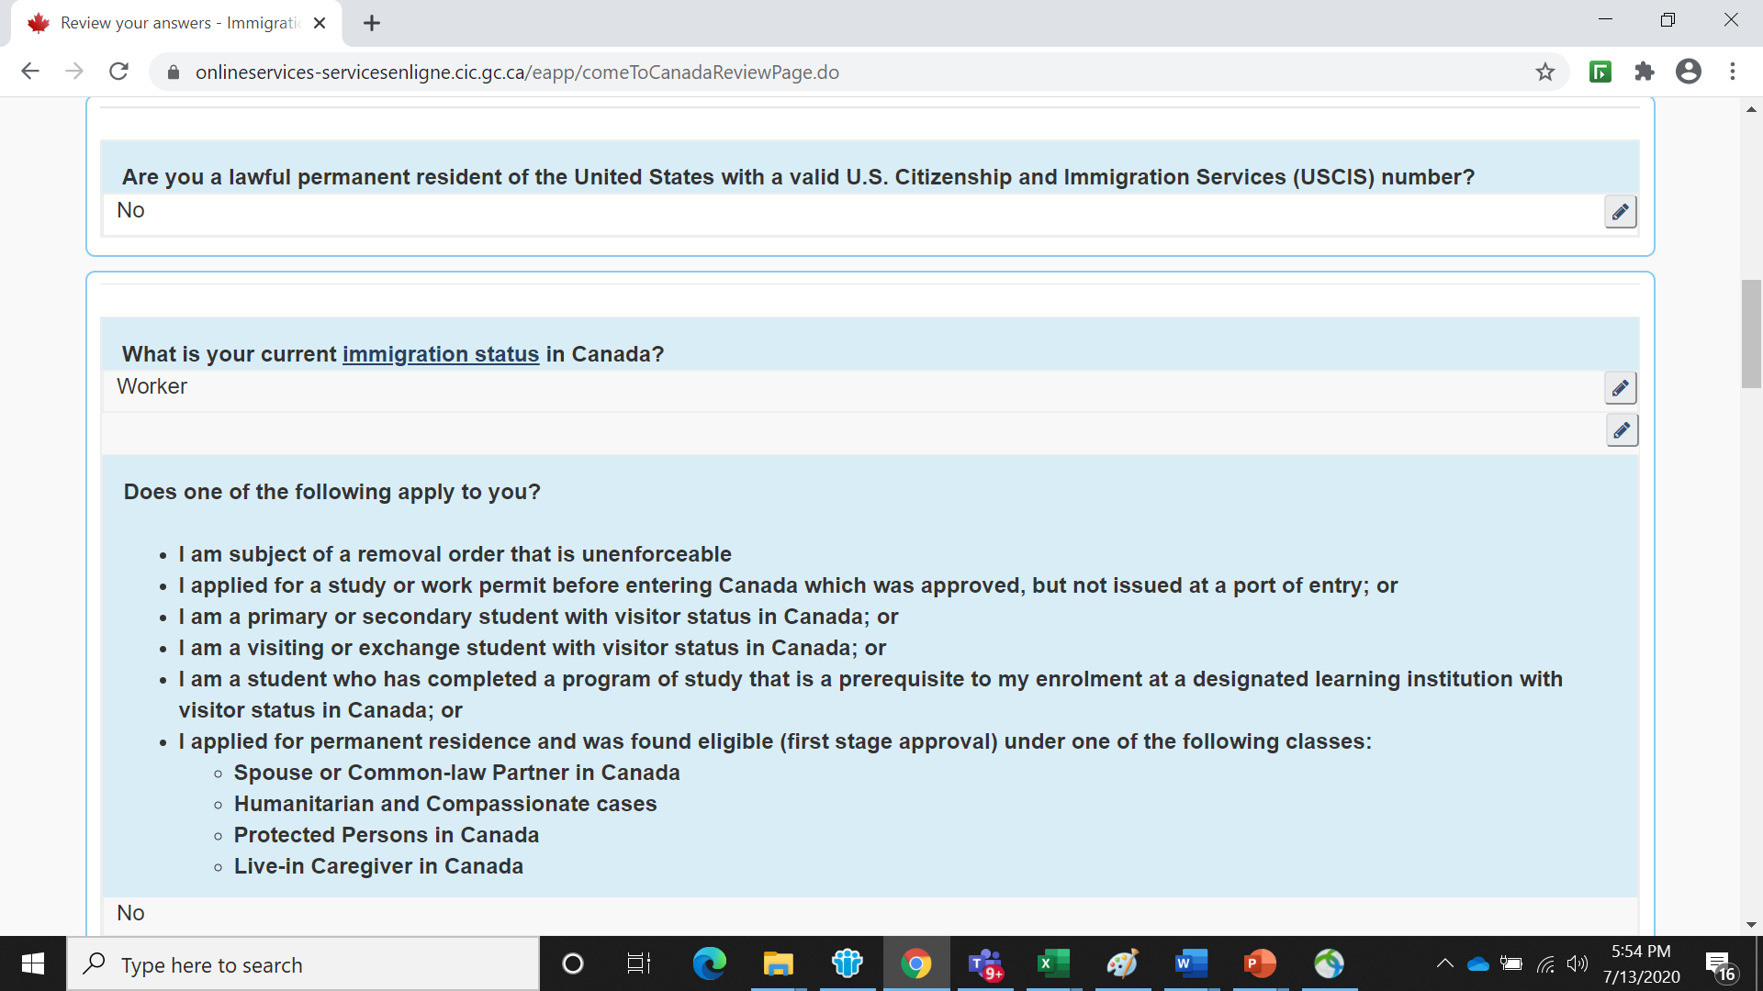

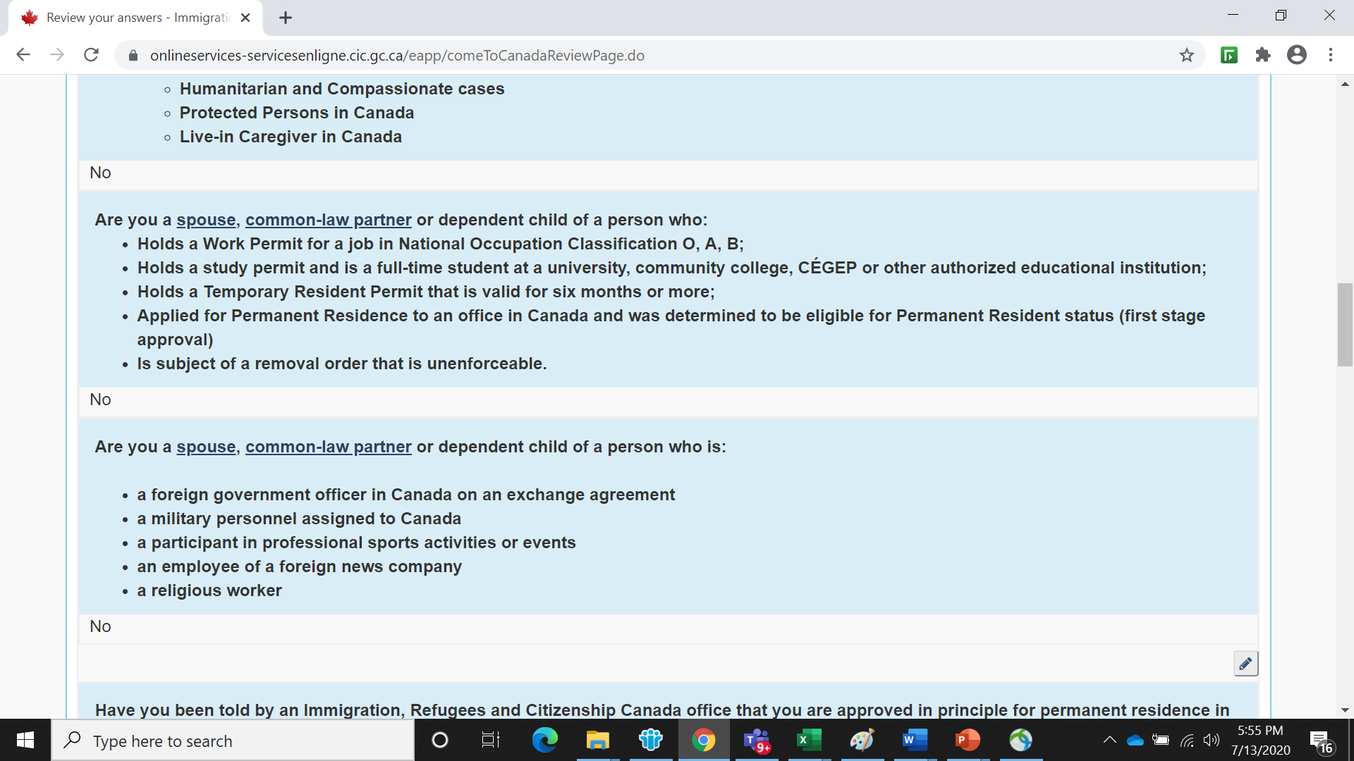

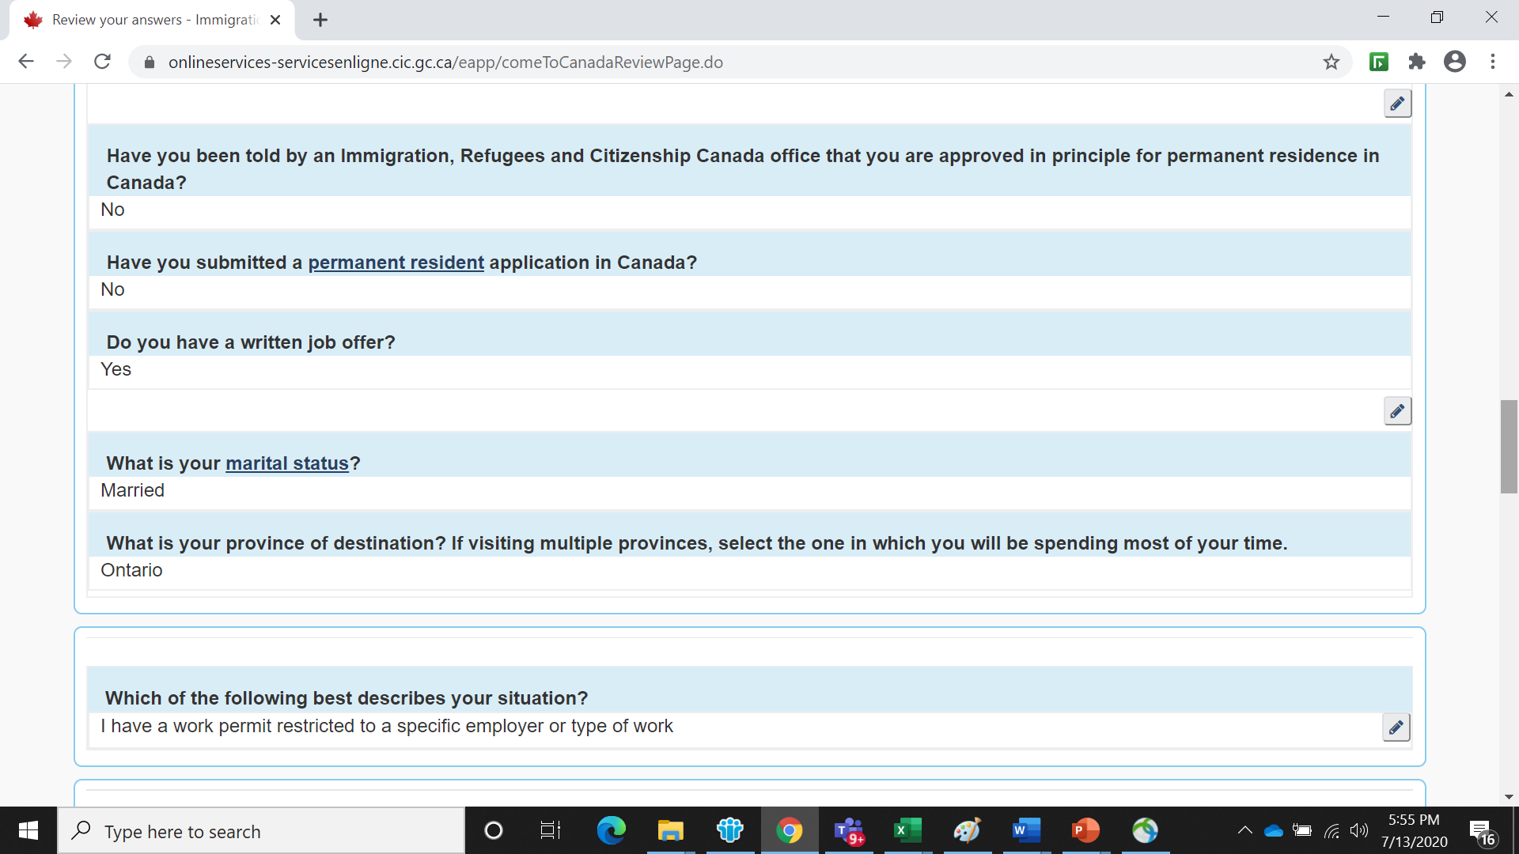

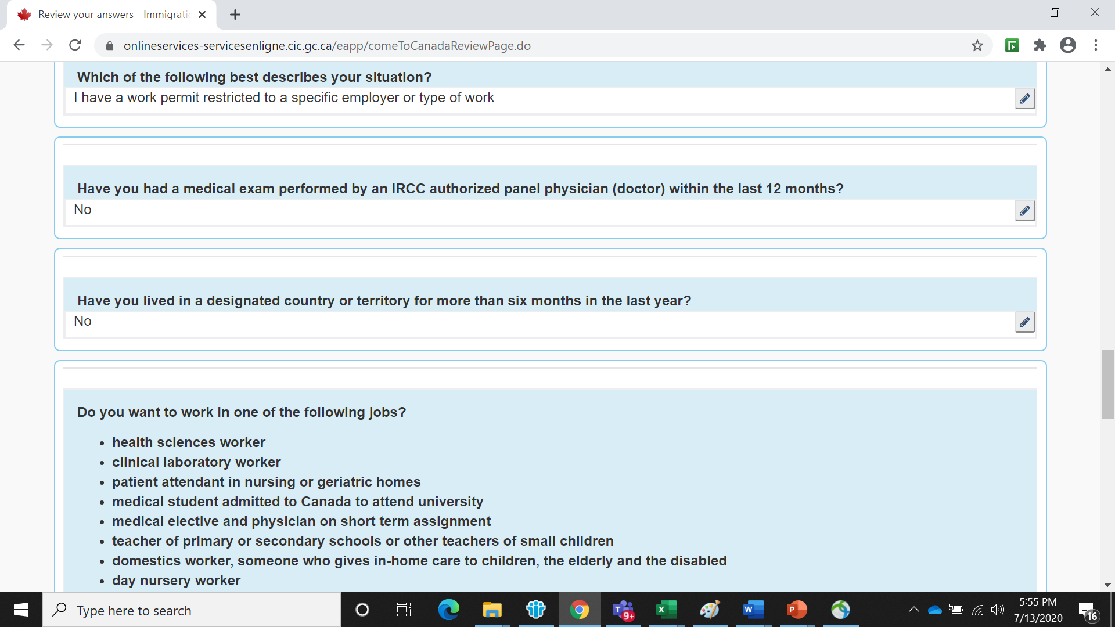

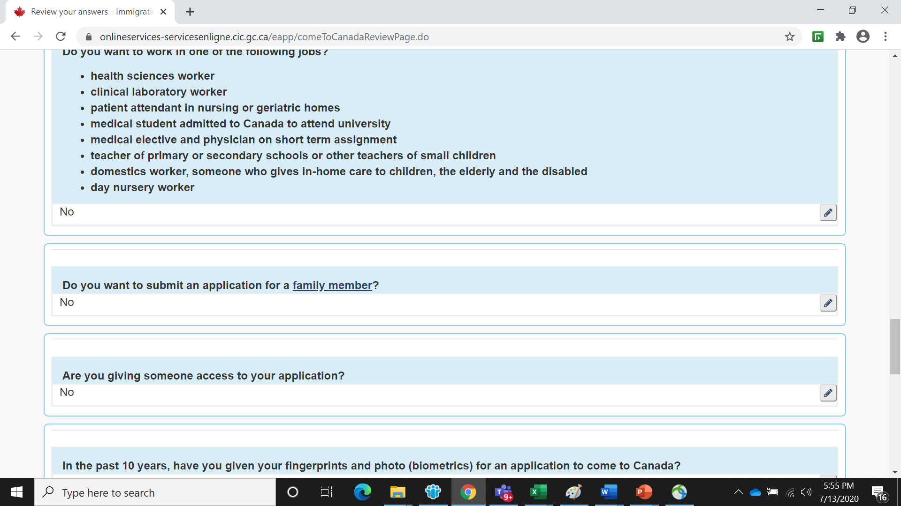

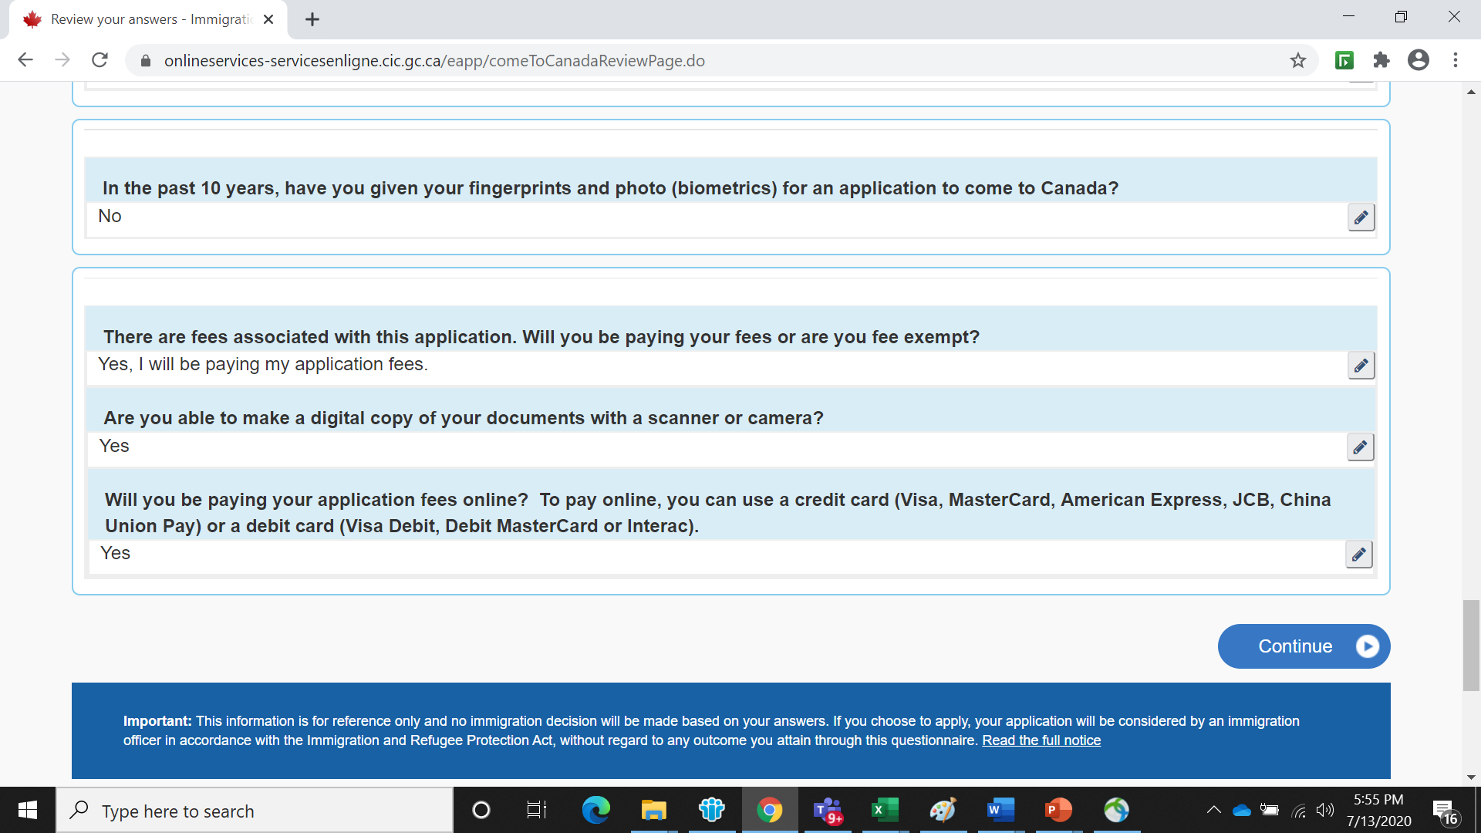

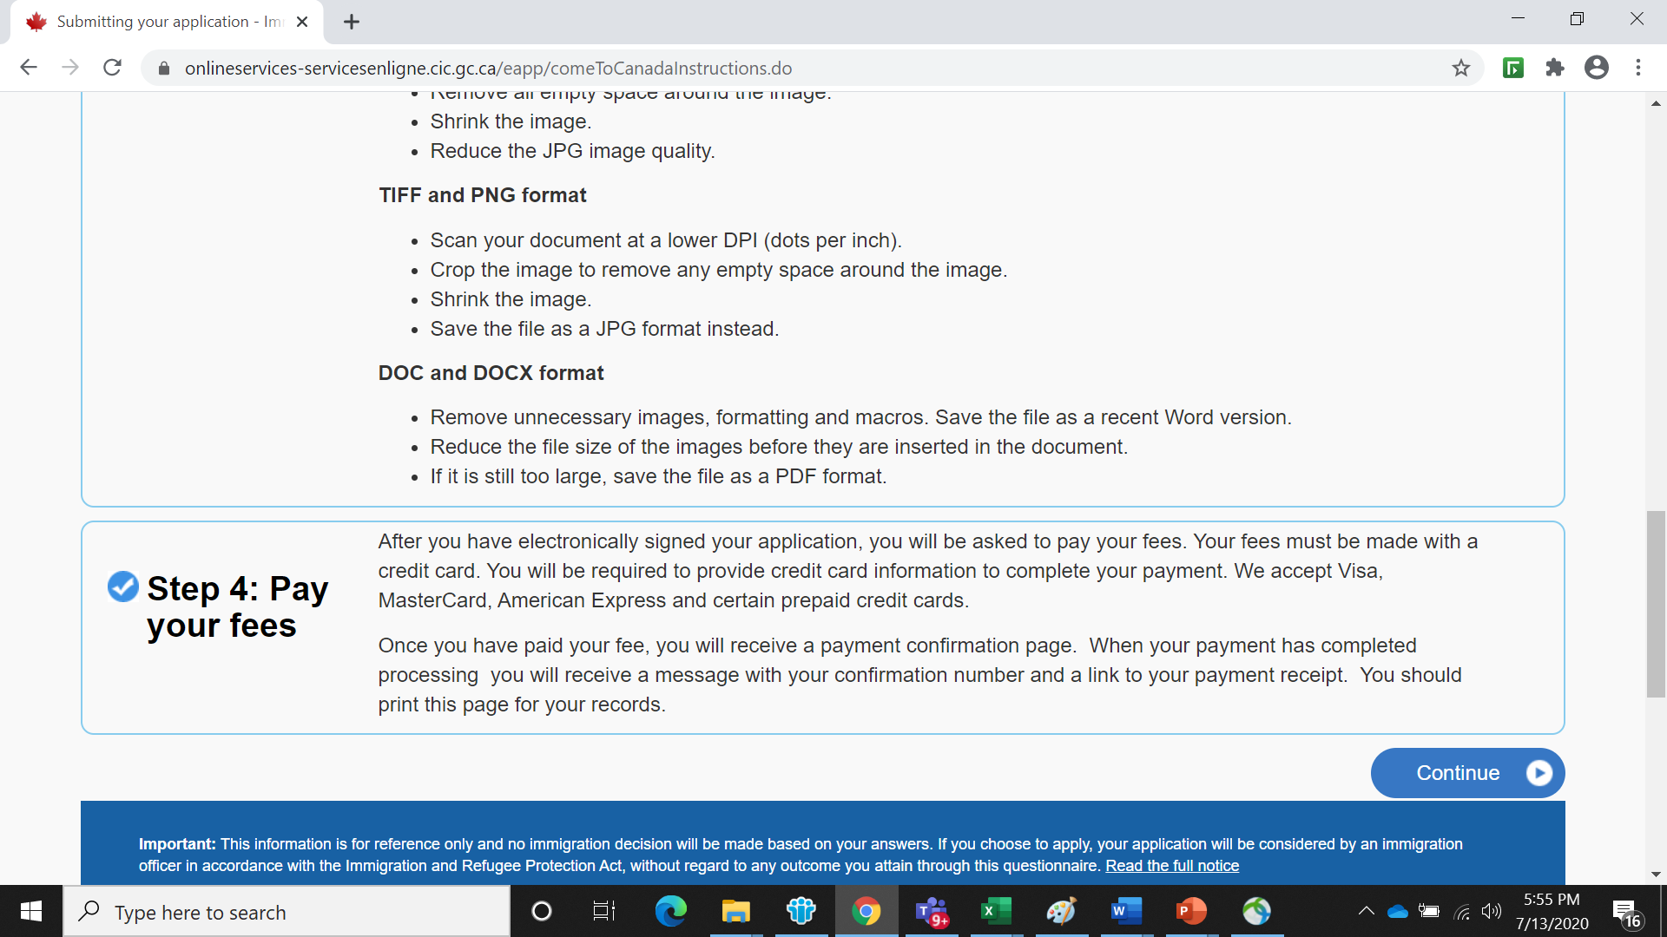

You should upload all the below required documents.

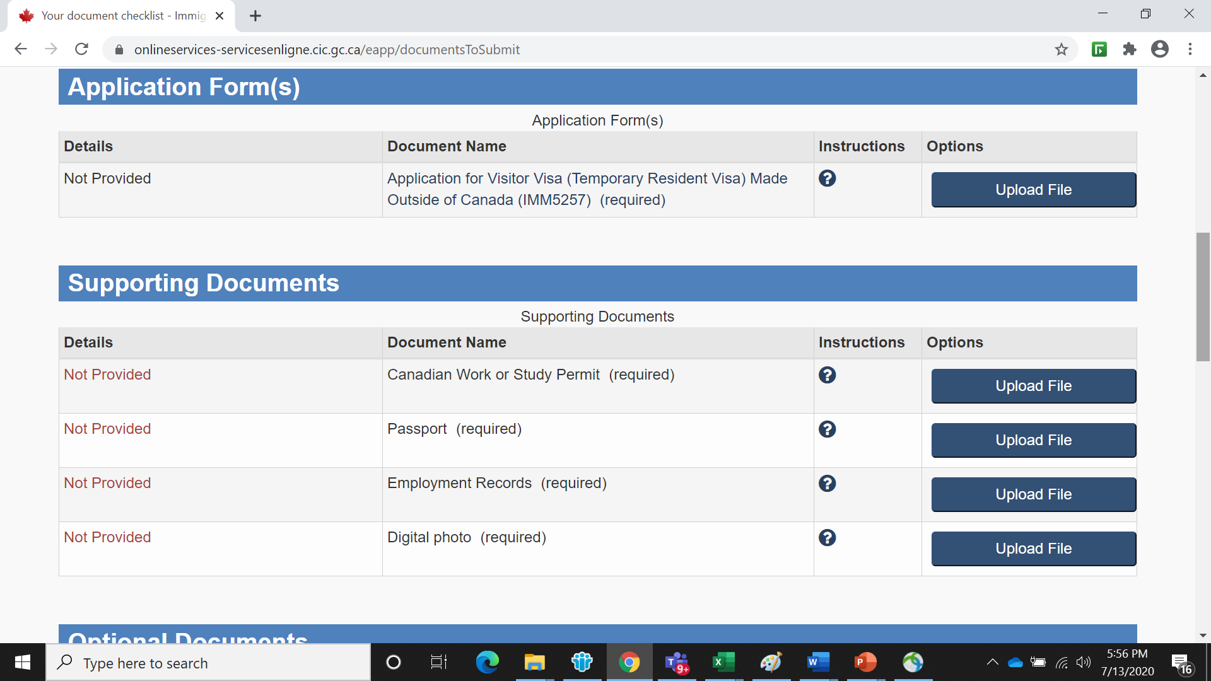

You can ignore the optional documents.

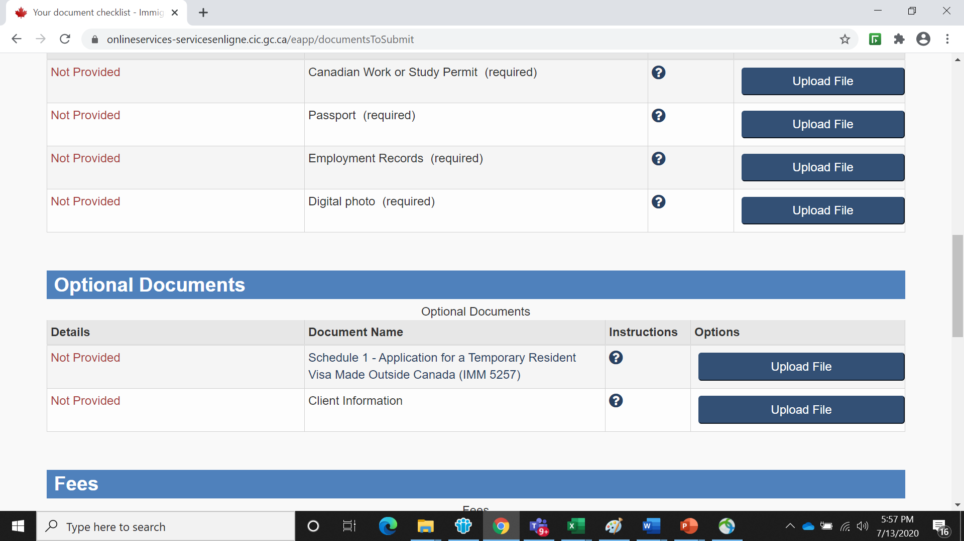

Upload the documents first and pay the fees next and then transmit/submit the documents.

Once documents submitted along with the required fees, IRCC will take 2 weeks to review and approve the profile. Once approved, IRCC will issue the white approval letter with the proper instruction to send the passport via courier or Canada post. Simply follow the instruction given in the approval letter after 2 weeks.

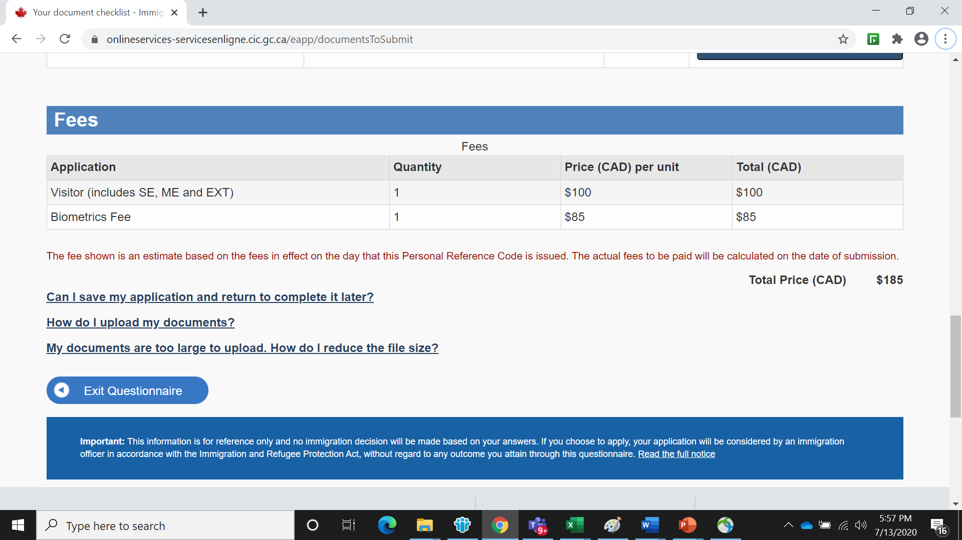

**Applying Visa stamping in the passport for Students**

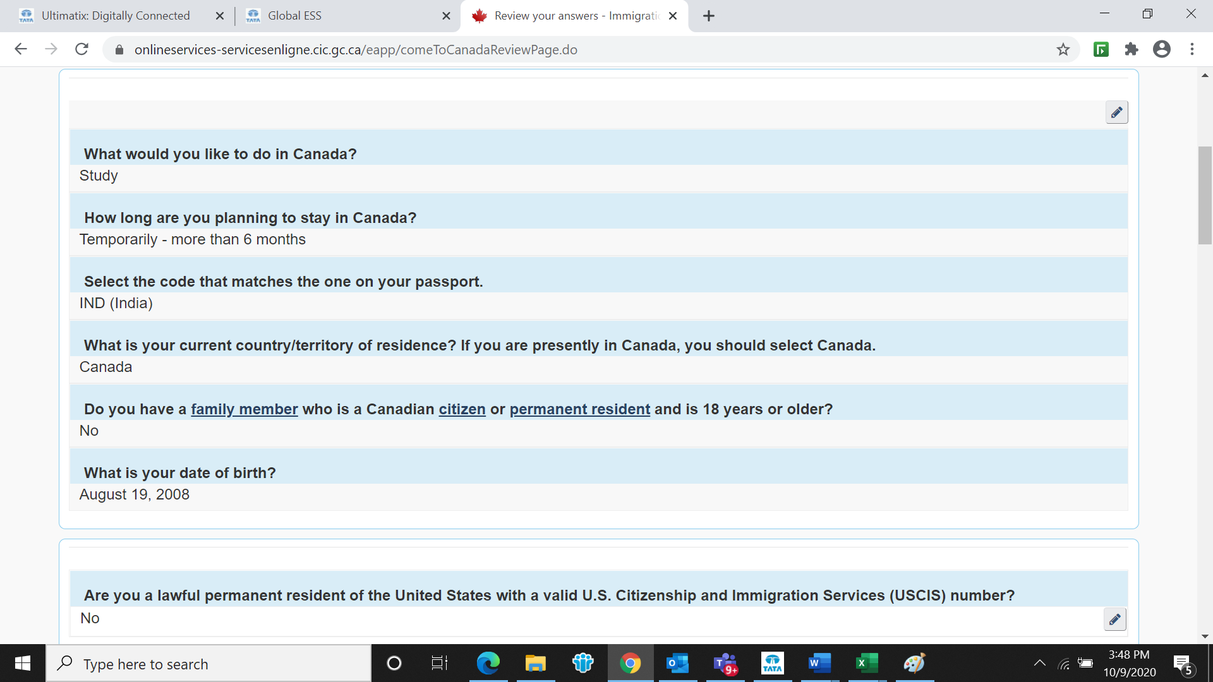

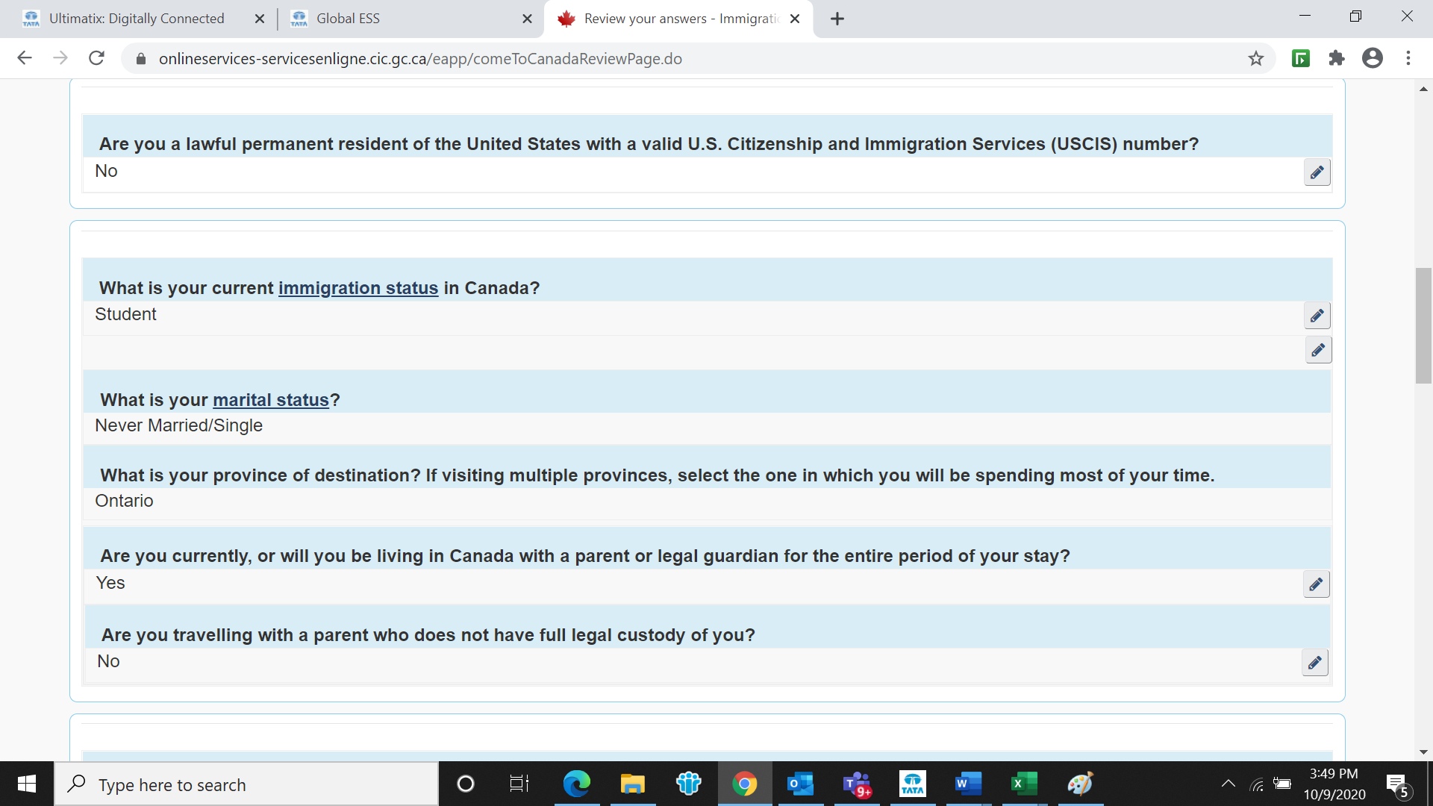

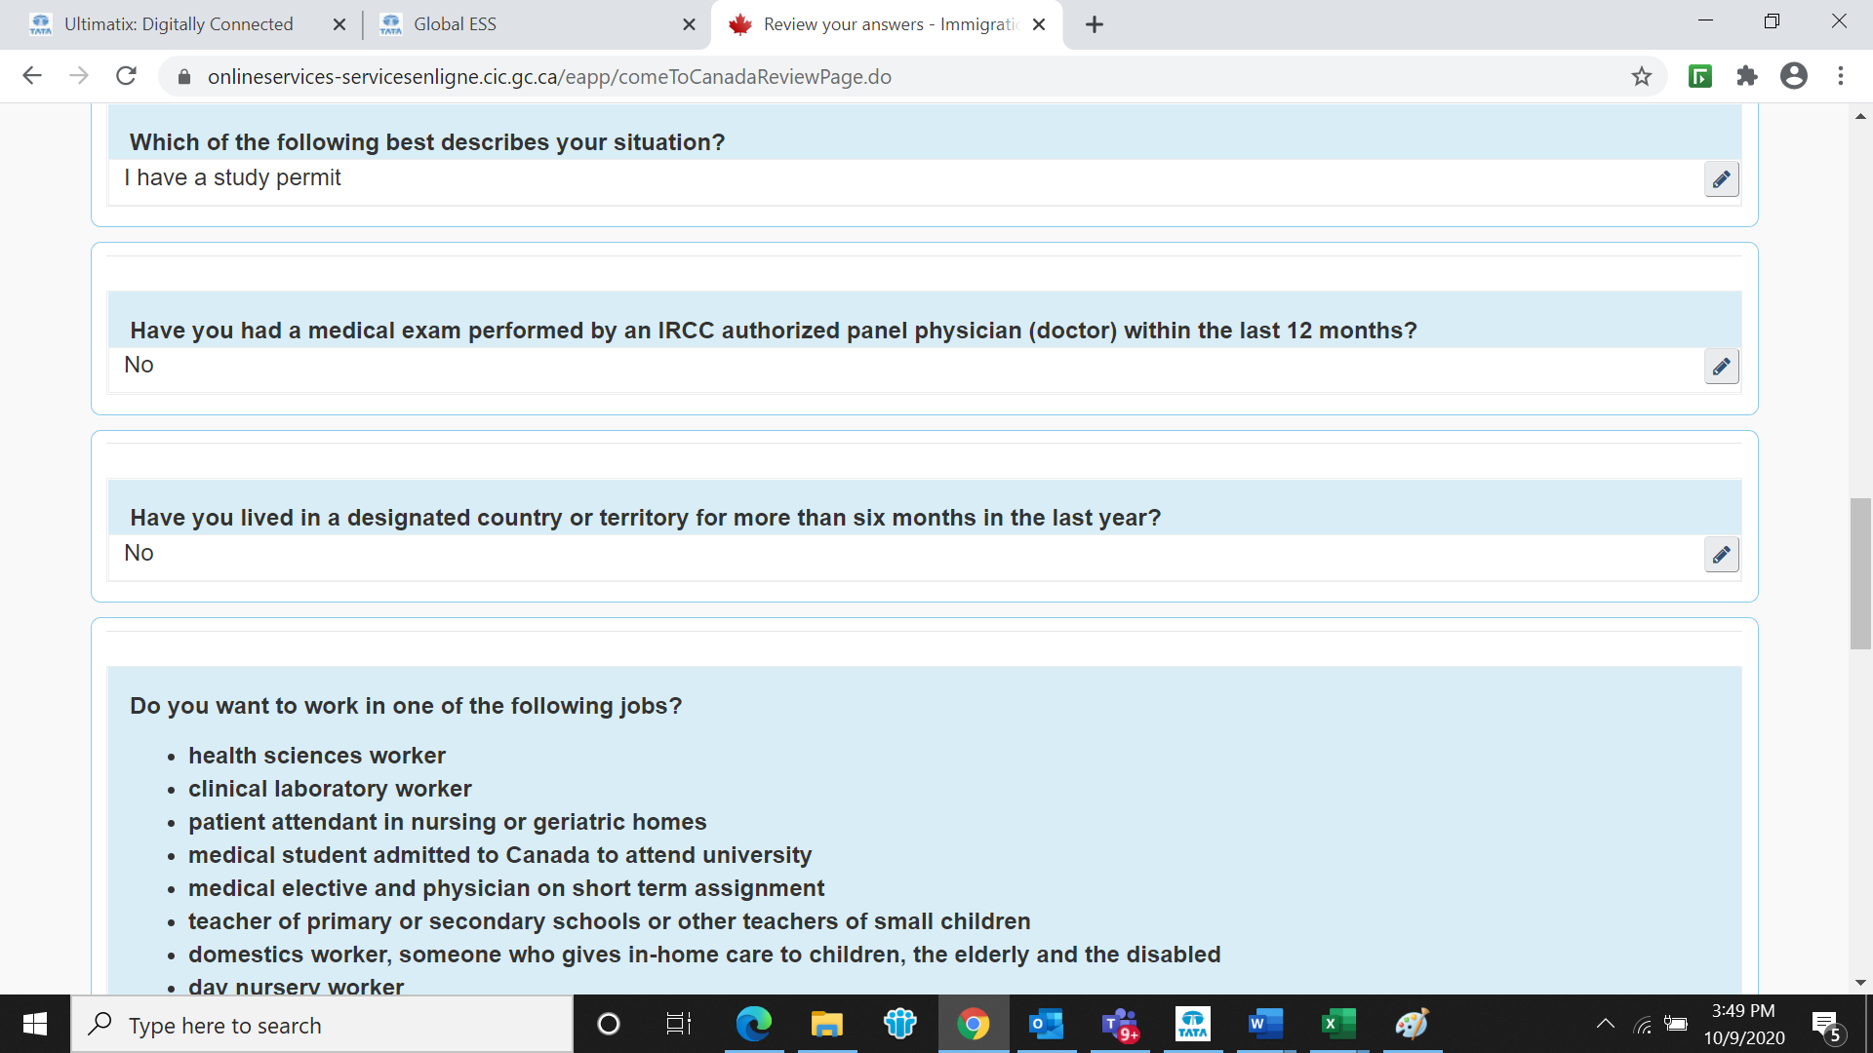

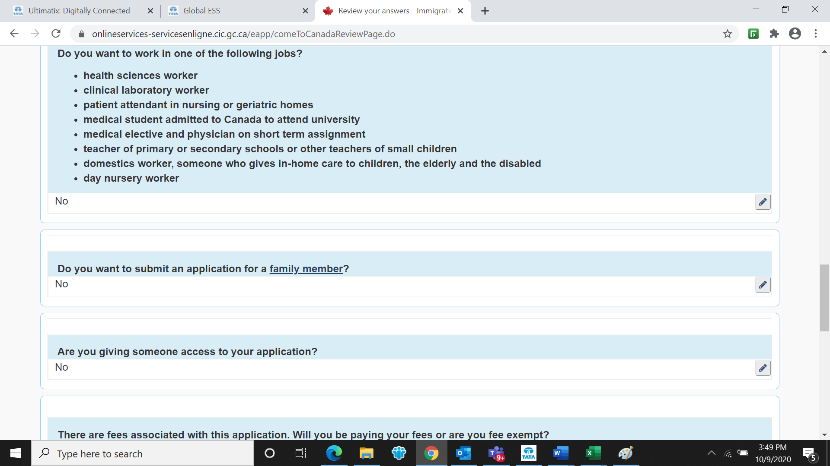

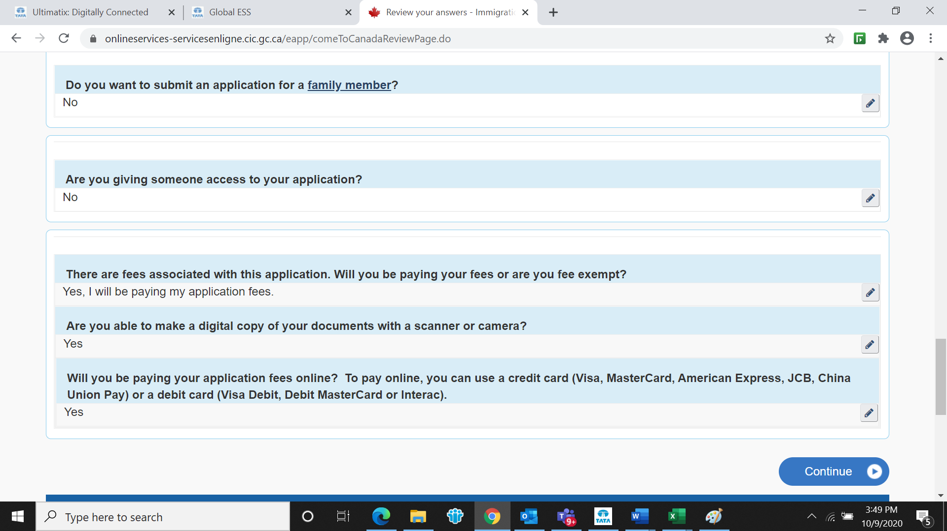

For Students also please create a seaprate online profile and select “ Temporary Resident Visa” as mentioned in the below screenshot. (Do not select Study Permit)

